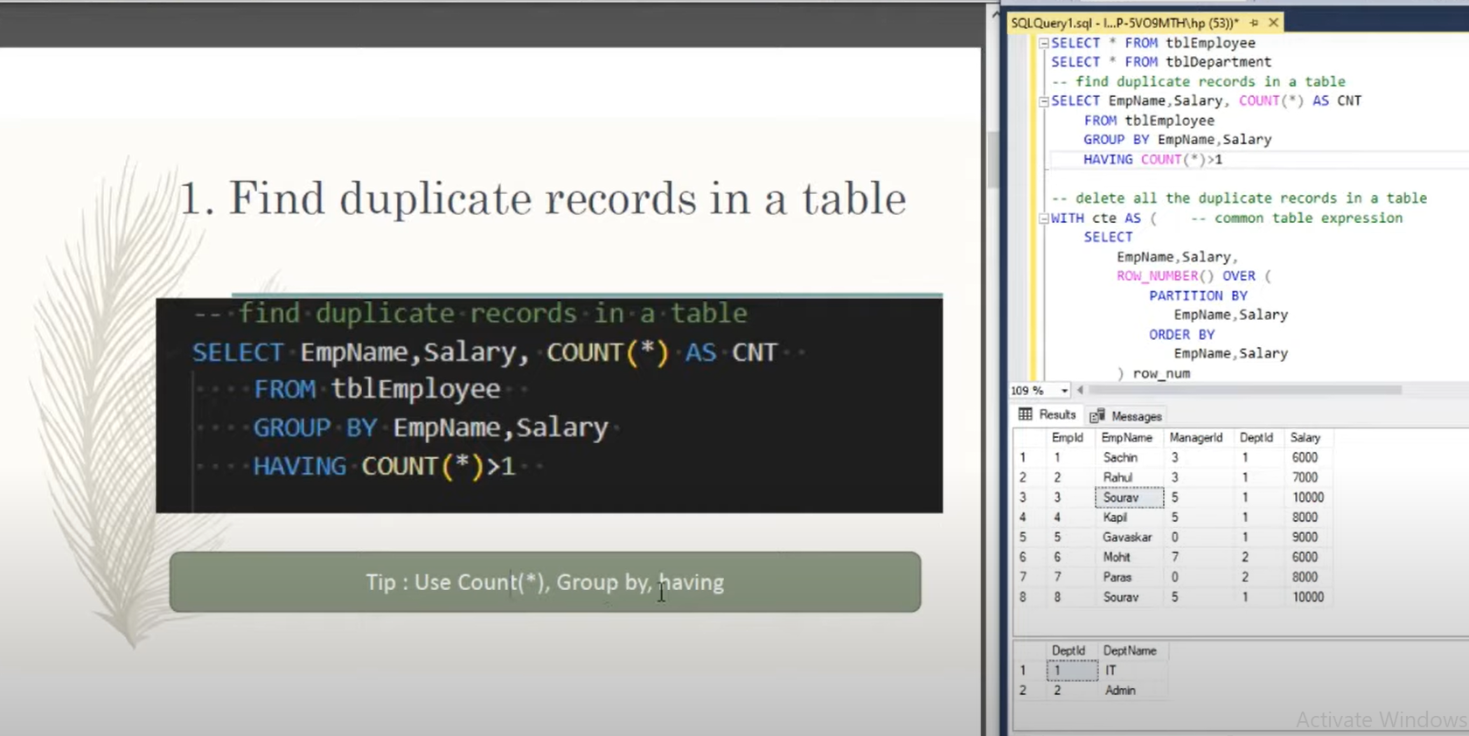

So if we are using any aggregate function like count then necessary we have to use group by the column name what we are selecting and if we need to write any condition then instead of wrap we used to write under having clauses.

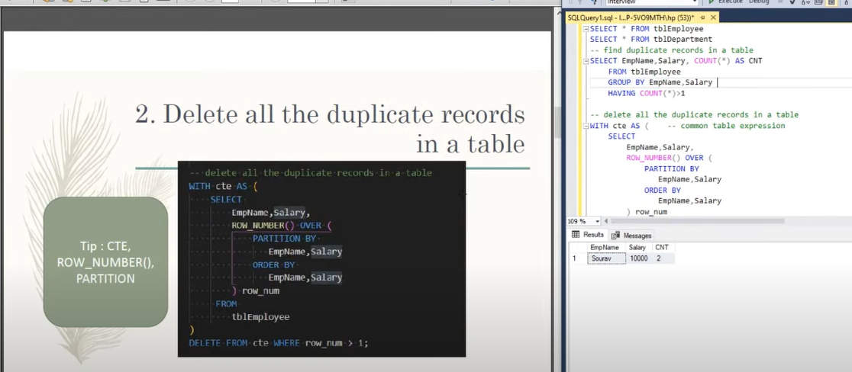

CDE- Common table expression

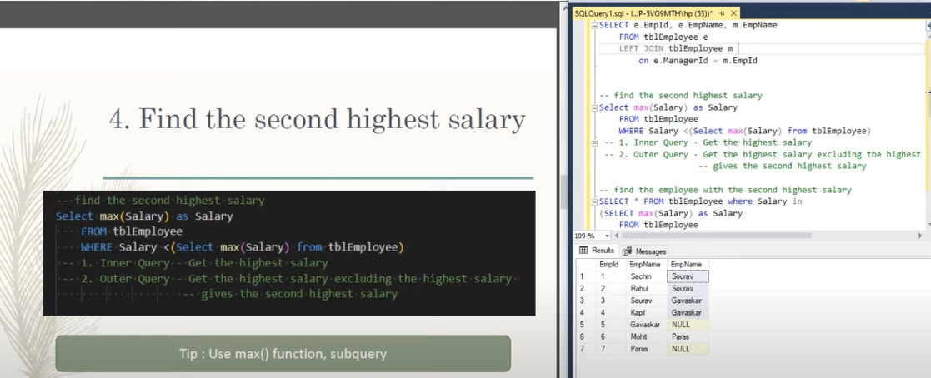

-- FIND DUPLICATE RECORD IN THE TABLE

SELECT EMP_NAME, SALARY, dept_id, COUNT(*) AS CNT FROM OFFICE.emp_detail group by SALARY, EMP_NAME, DEPT_ID HAVING COUNT(*)>0;

-- FIND THE SECOND HIGHEST SALARY

SELECT MAX(SALARY) AS SALARY FROM EMP_DETAIL WHERE SALARY < (SELECT MAX(SALARY) FROM emp_detail);

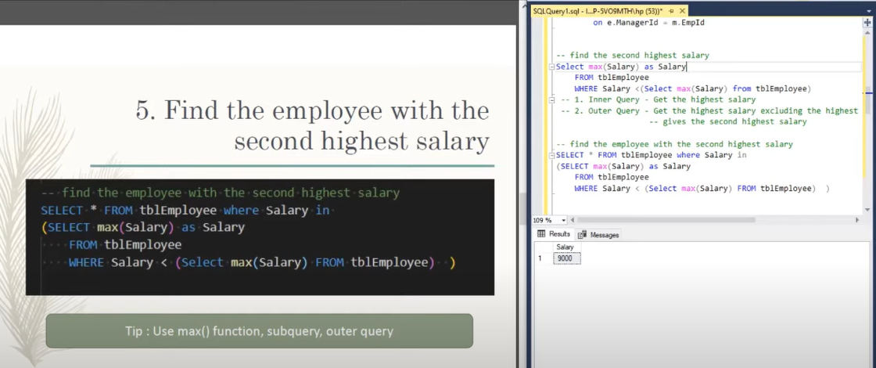

SELECT * FROM EMP_DETAIL WHERE SALARY IN (SELECT MAX(SALARY) AS SALARY FROM EMP_DETAIL WHERE SALARY <(SELECT MAX(SALARY) FROM EMP_DETAIL));

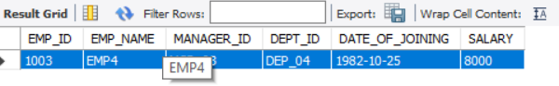

|  |  |  |  |  |  |
| --- | --- | --- | --- | --- | --- |
|  |  |  |  |  |  |

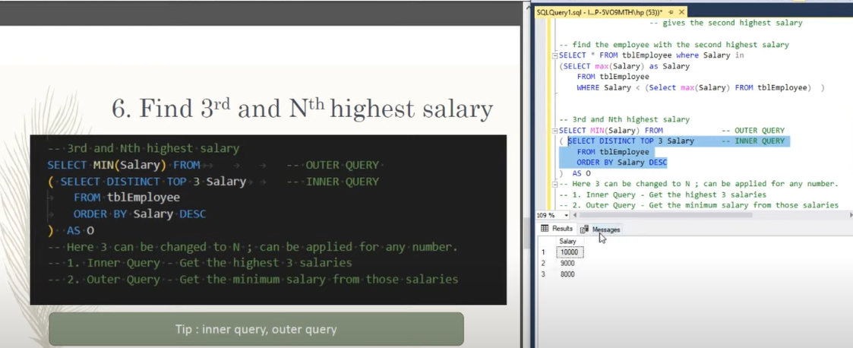

SELECT MIN(SALARY) FROM (SELECT DISTINCT SALARY FROM emp_detail order by SALARY DESC LIMIT 4) AS LOWEST;

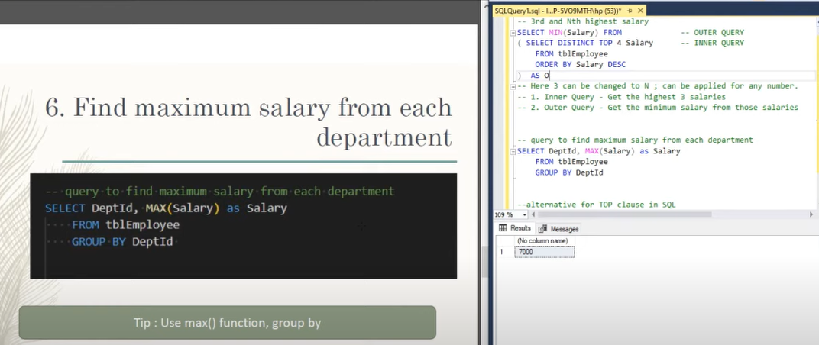

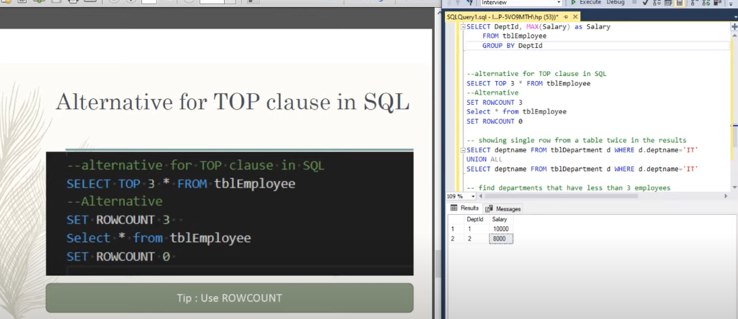

SELECT * FROM emp_detail order by SALARY DESC LIMIT 4

TOP 4 RECOND OF EMPLEE BASED ON SALARY

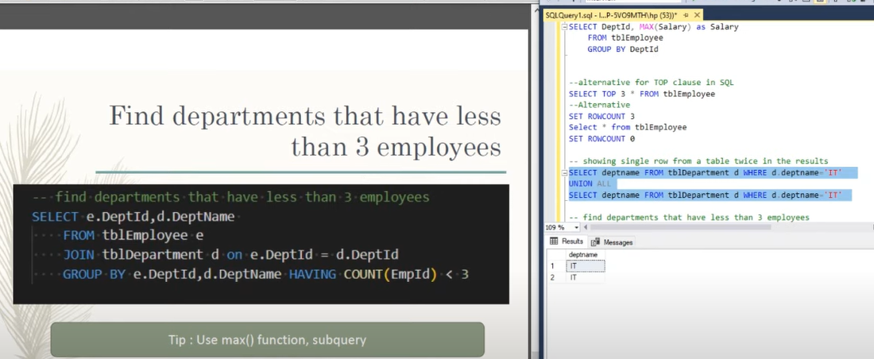

Difference between function and procedures:

**Difference between Function and Procedure**

* Last Updated : 18 Dec, 2019

**Function:**   
It is one among the fundamental thought in the computer programming. It is used to calculate something from a given input. Hence it got its name from Mathematics. Function can be either user defined or predefined. The function program has a block of code that performs some specific tasks or functions.

**Procedure:**   
In programming a particular set of instructions or commands along known as a procedure. Counting on the programming language it is known as as procedure, subroutine, function or a subprogram.

**Difference between Function and Procedure:**

| S.NO | Function | Procedure |
| --- | --- | --- |
| 1. | A function deals with as an expression. | Whereas a procedure does not deal with as an expression. |
| 2. | Function is used to calculate something from a given input. Hence it got its name from Mathematics. | While procedure is the set of commands, which are executed in a order. |
| 3. | The function can be called by a procedure. | But a procedure cannot be called by a function. |
| 4. | In sql, inside the function we cannot use the DML(Data manipulation language) commands such as Insert, Delete, Update. | Here, in sql, inside the procedure we can use DML commands. |
| 5. | Functions can be called through sql queries. | However, the procedure can’t be called through a sql query. |
| 6. | Each time functions are compiled when they are called. | Whereas, procedures are compiled only once and can be called again and again as needed without being compiled each time. |
| 7. | The return statement of a function returns the control and function’s result value to the calling program. | While the return statement of the procedure returns control to the calling program, it cannot return the result value. |
| 8. | Function doesn’t support try-catch blocks. | While it supports try-catch blocks. |
| 9. | Function can be operated in the SELECT statement. | While it can’t be operated in the SELECT statement. |
| 10. | Function does not support explicit transaction handles. | While procedure supports explicit transaction handles. |

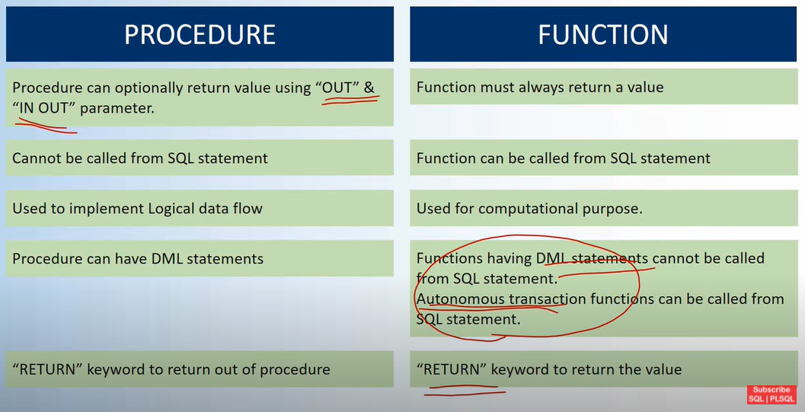

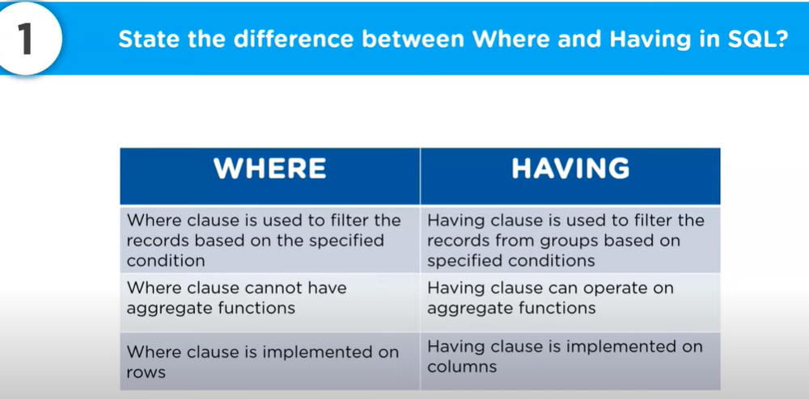

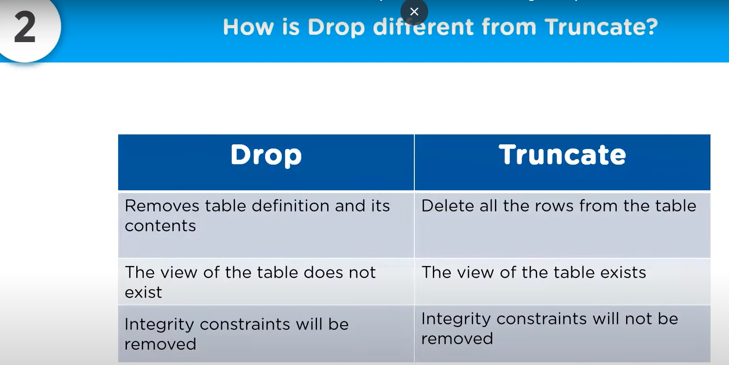

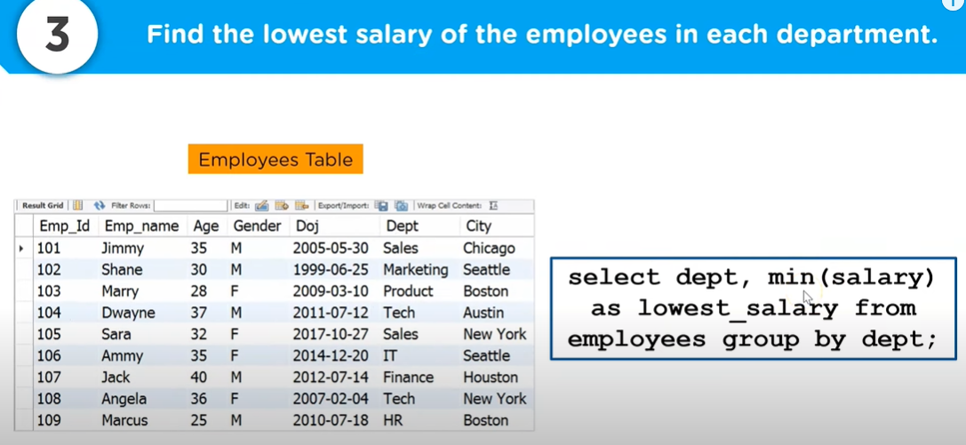

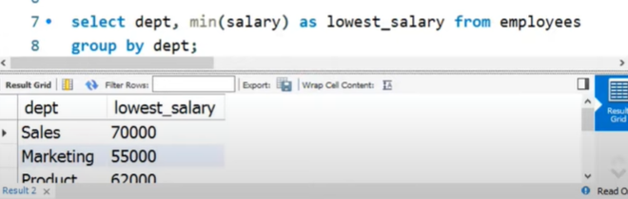

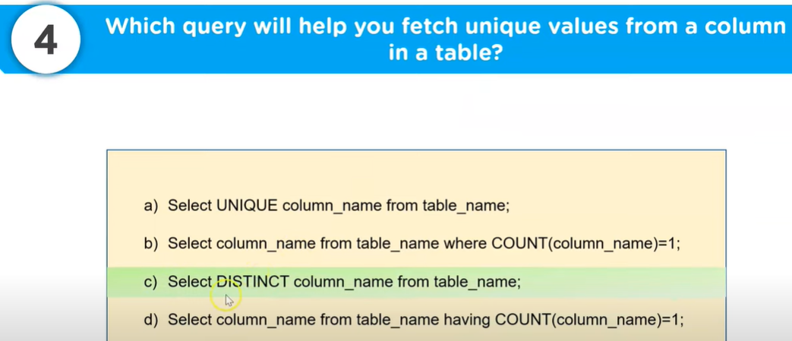

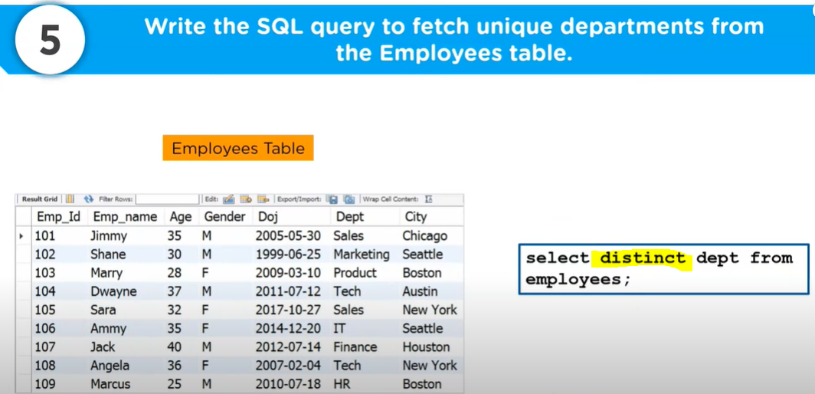

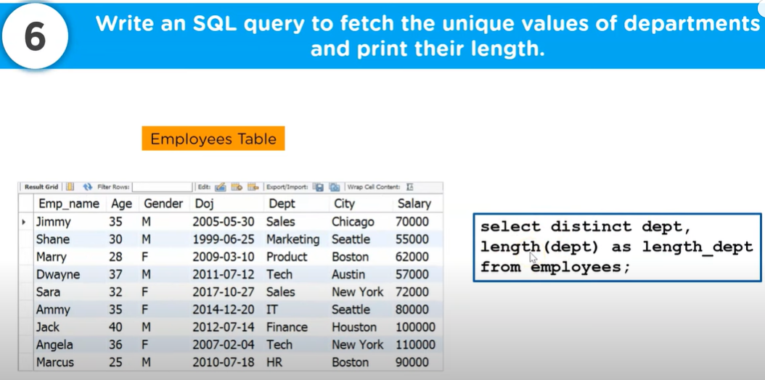

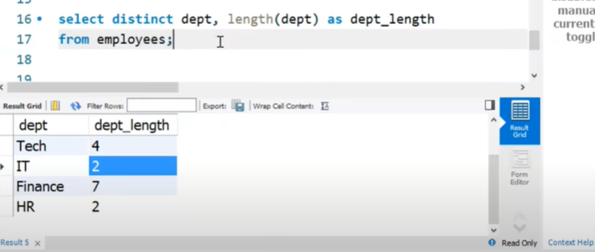

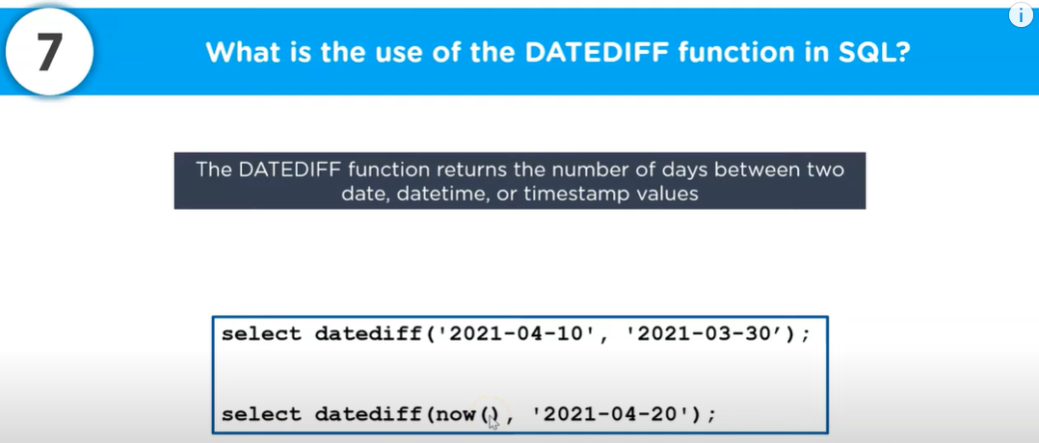

|  |  |
| --- | --- |
|  |  |

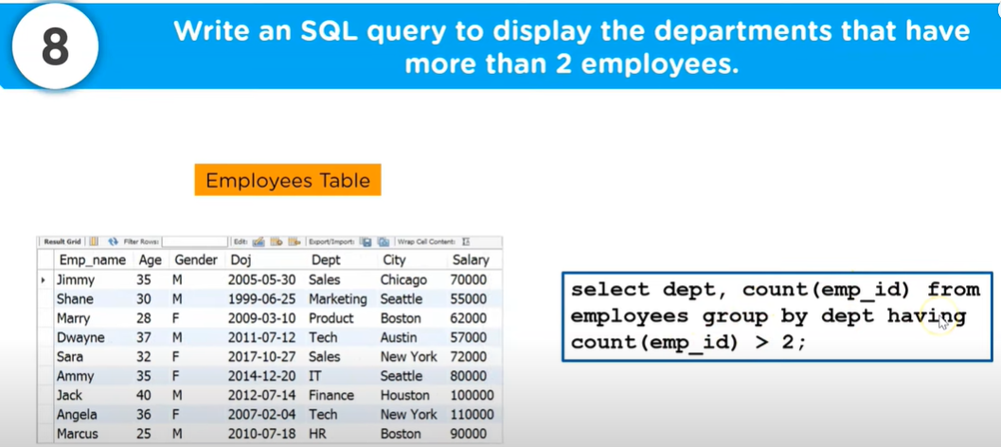

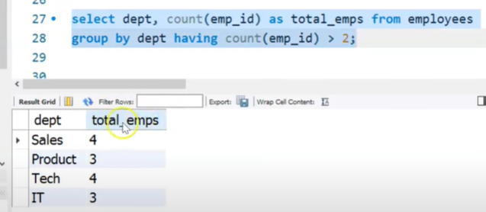

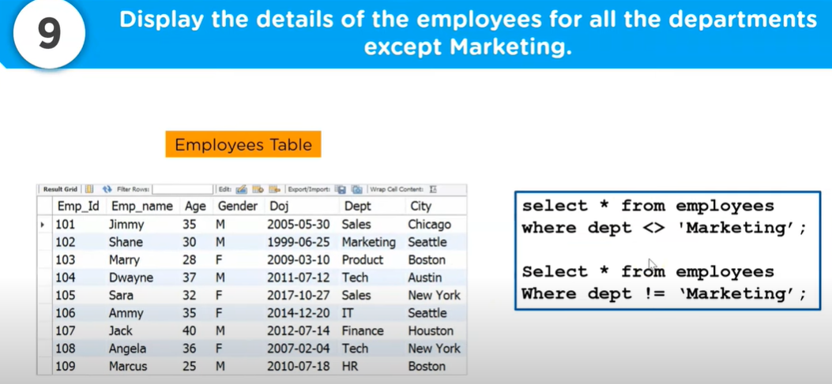

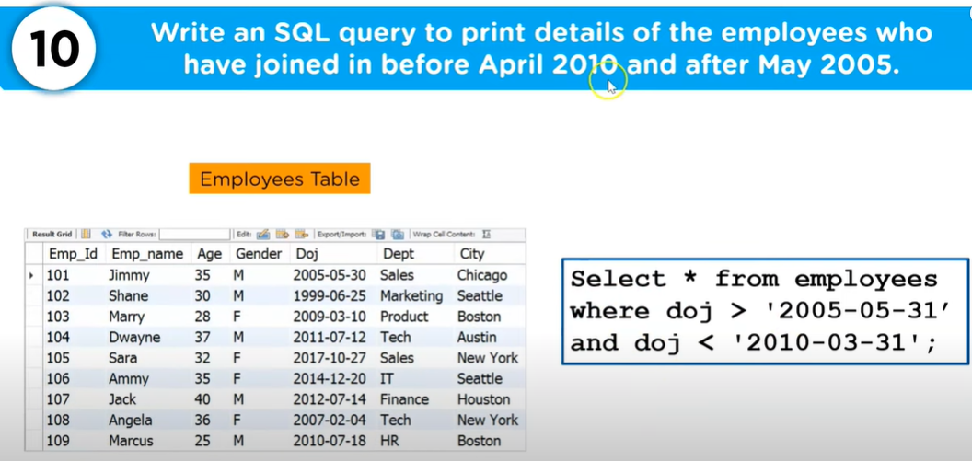

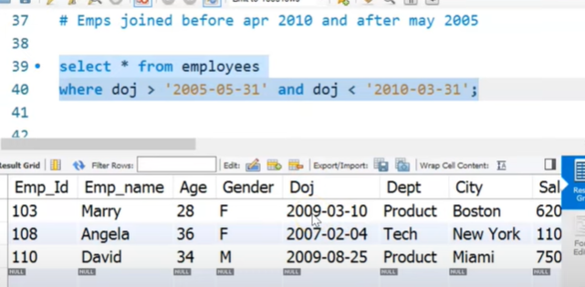

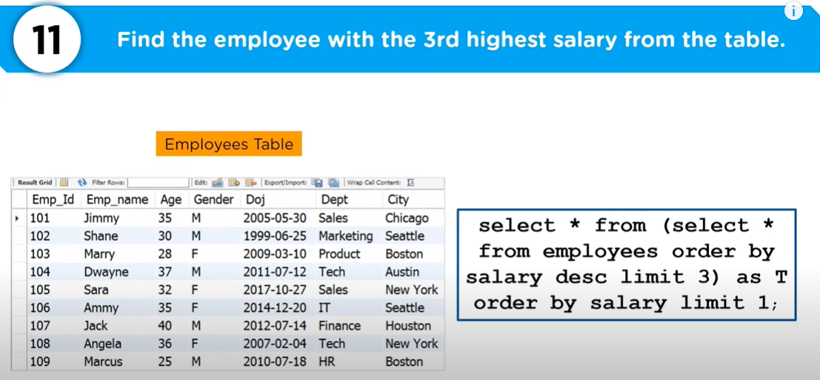

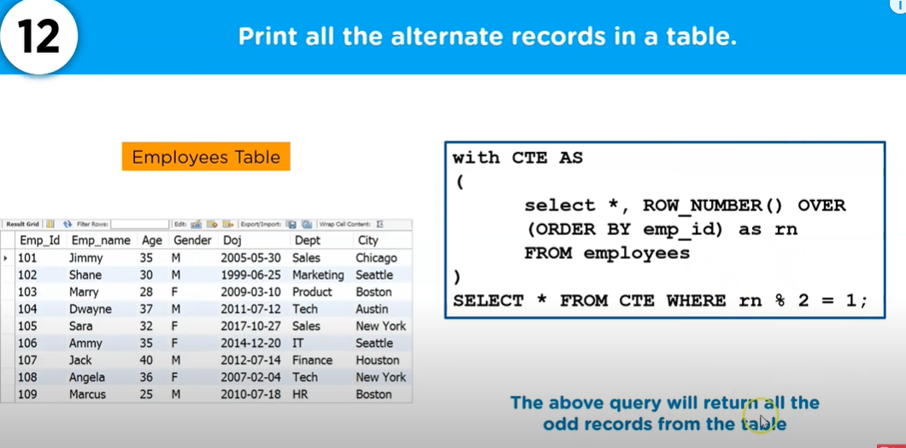

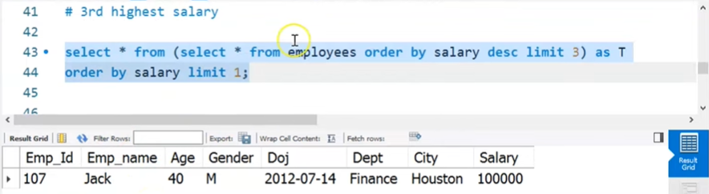

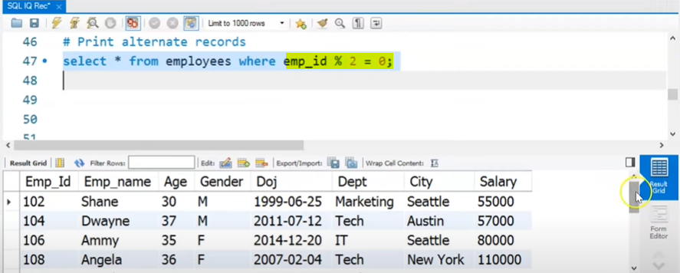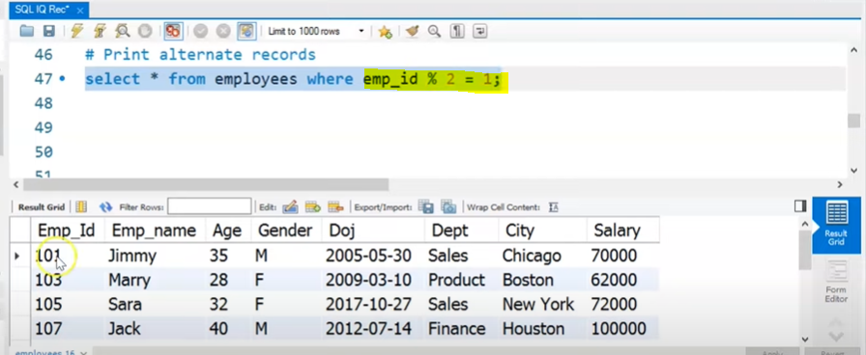 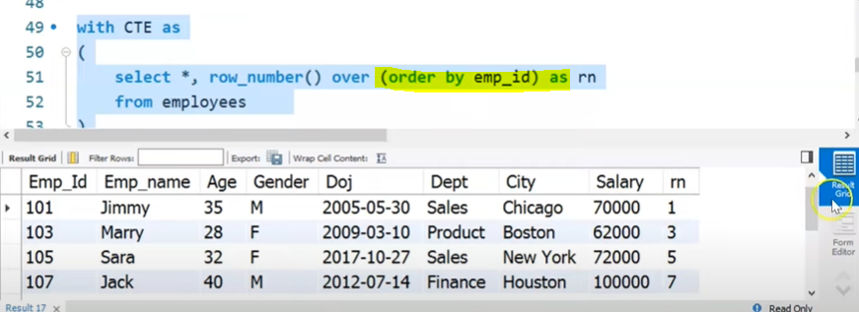

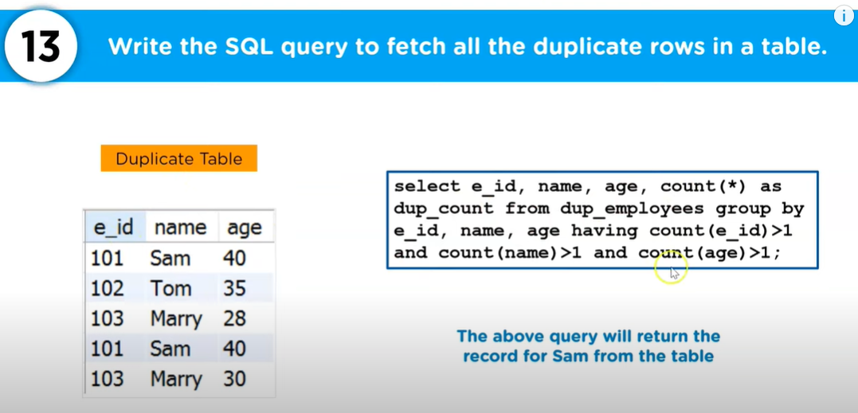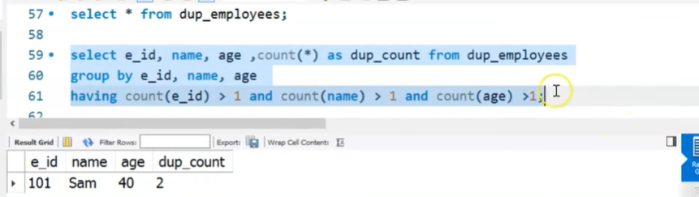

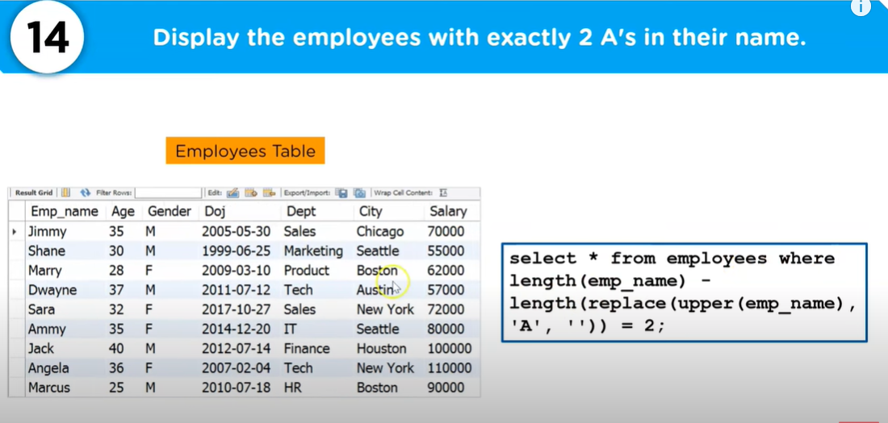

So first let’s find out change all the emp_name into upper case and then replace A with blank ‘ ‘ and then findout lenthg of the employee without A.

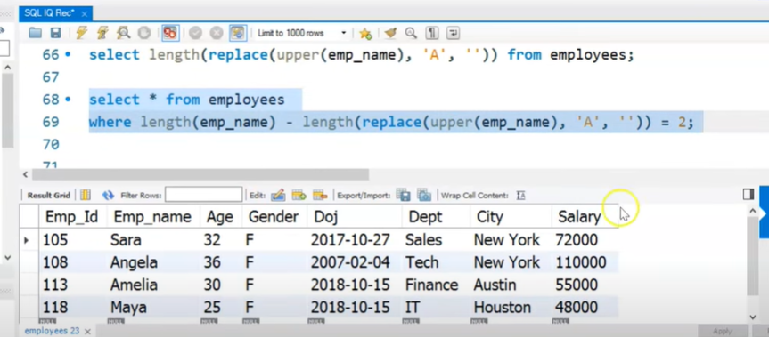

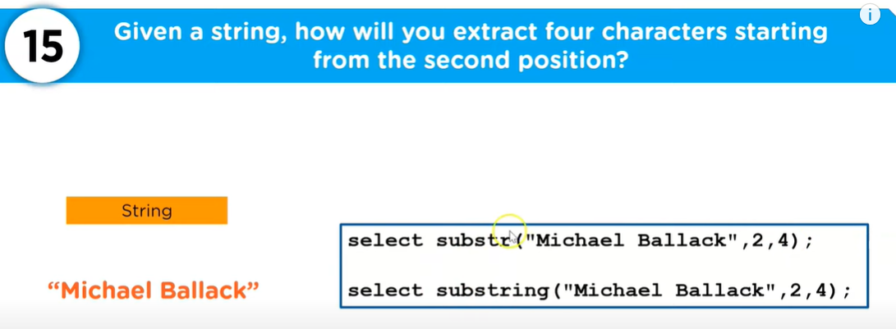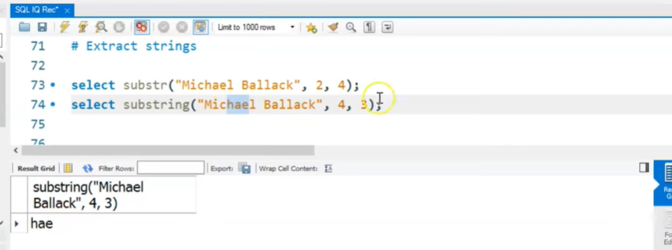

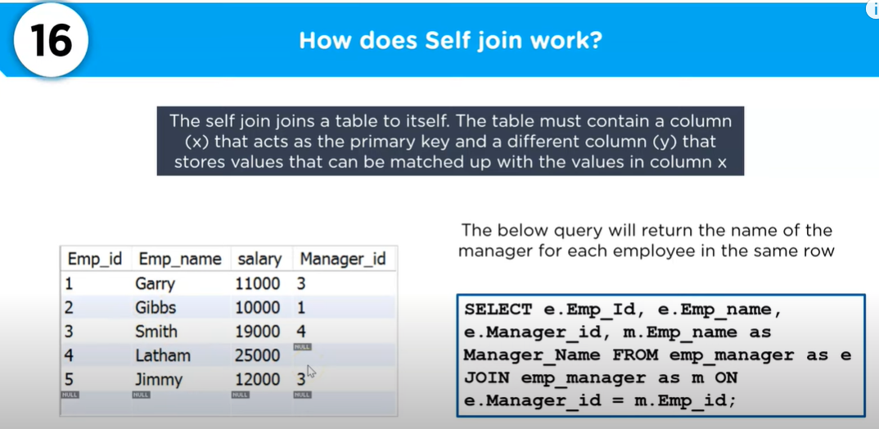 Garry manager is Smith , Gibbs Manager is Garry, Smith Manager is Latham, Jimmy Manager is Smith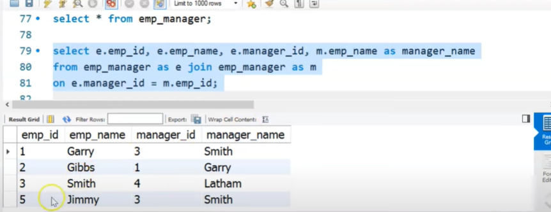

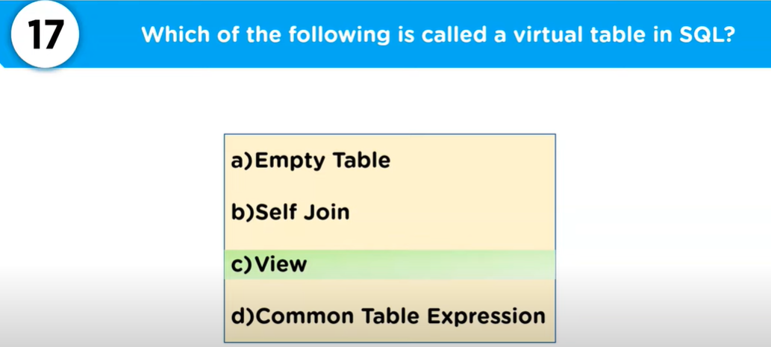

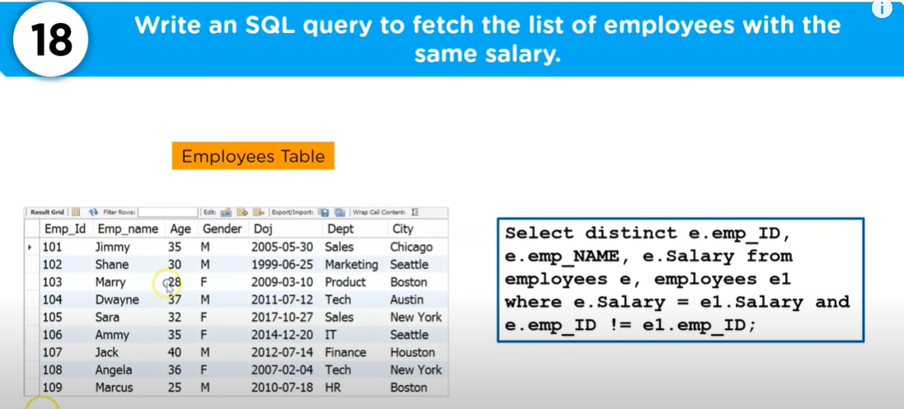Here also we will self join.

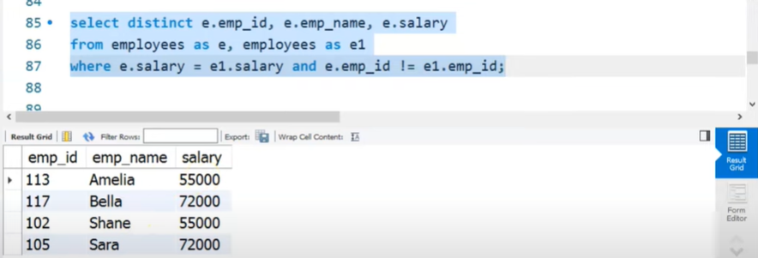

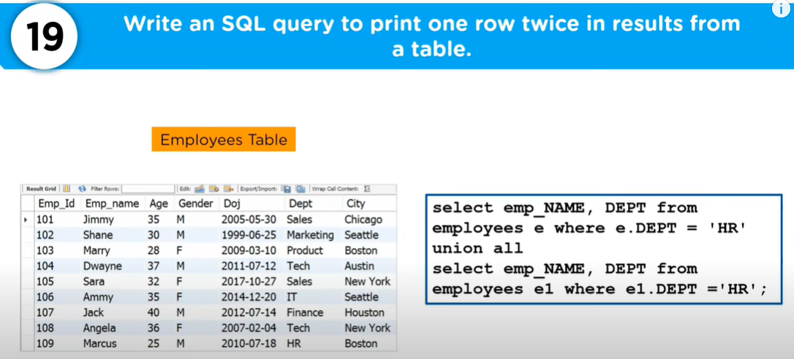

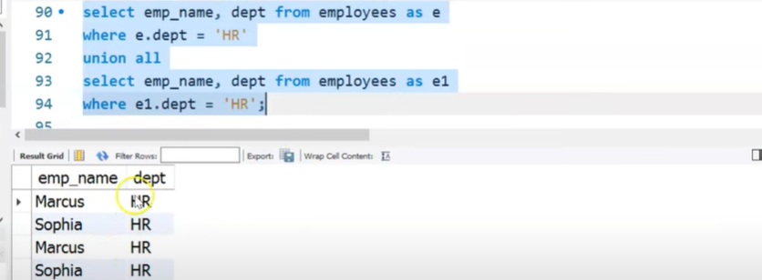

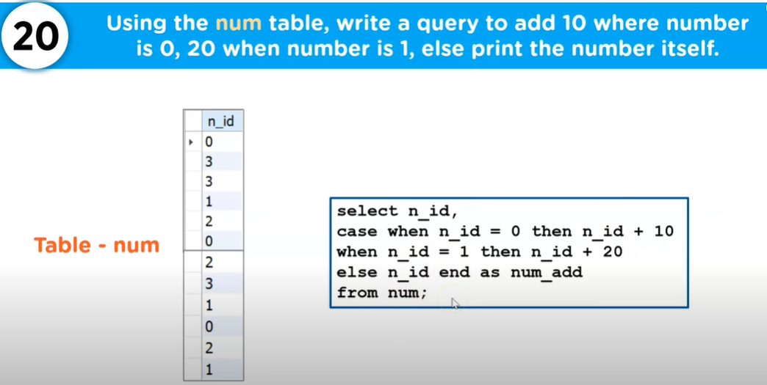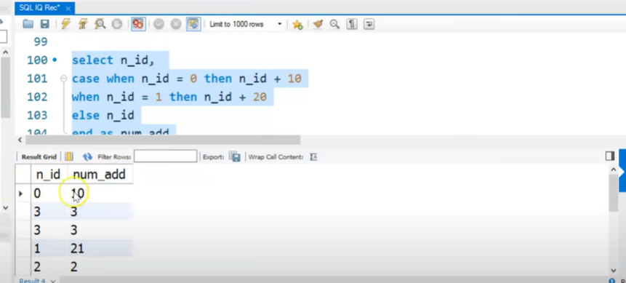

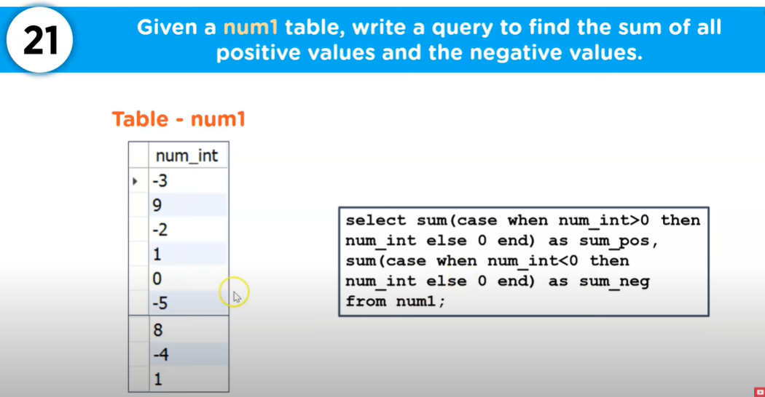

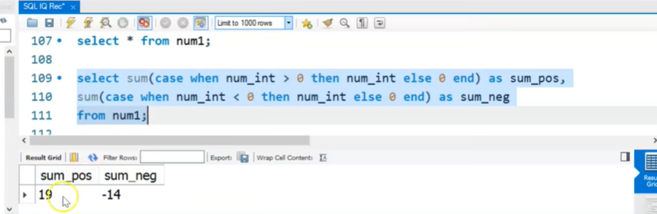

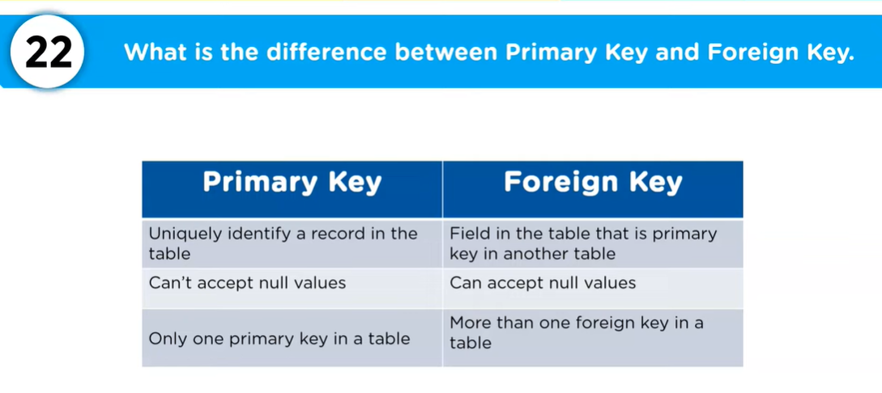

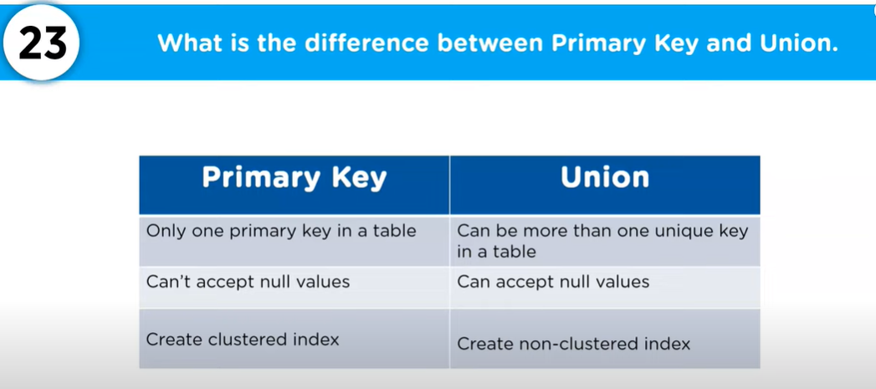 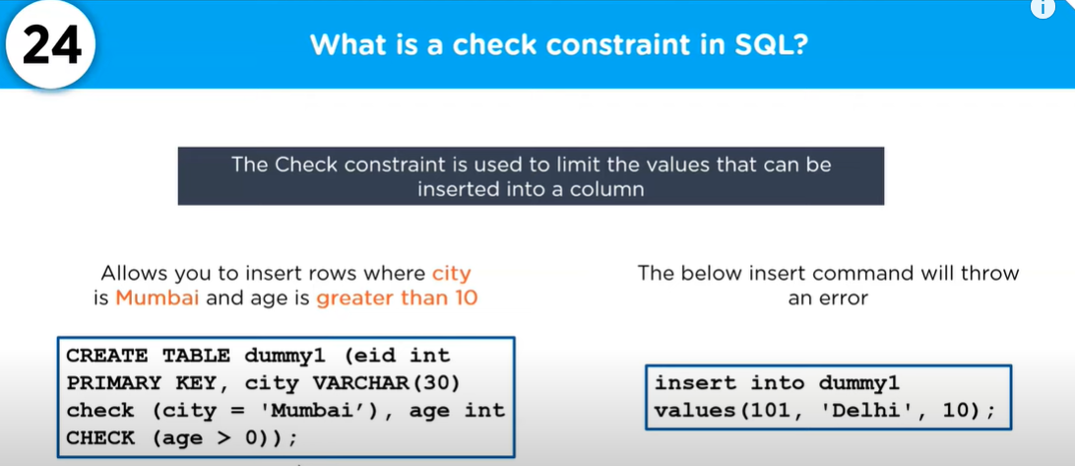

|  |  |
| --- | --- |
| Violated dummy_sql check because age according to check should be >0 | Violated dummy_sql check because city always should be Mumbai |

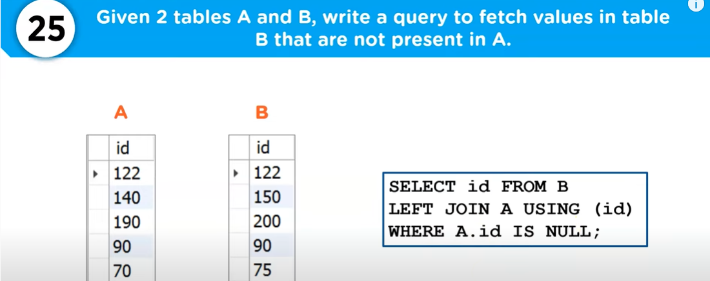 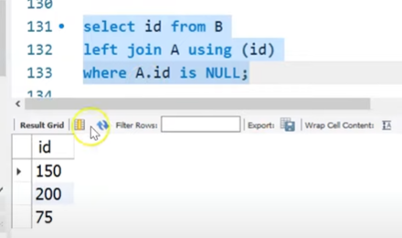

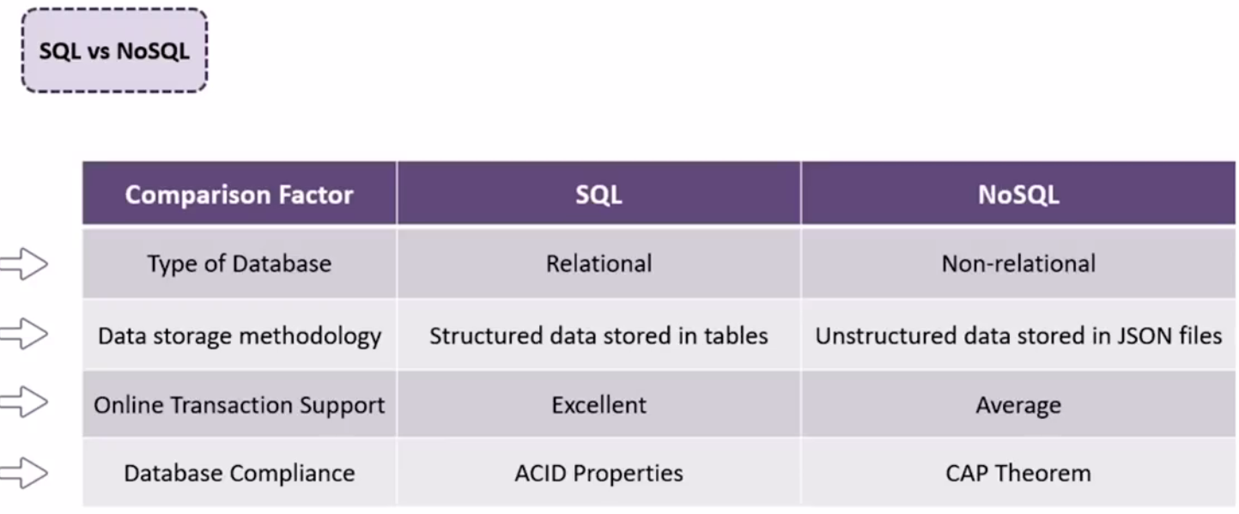

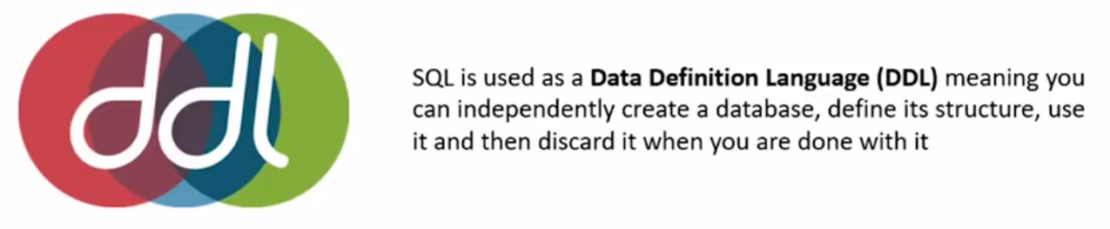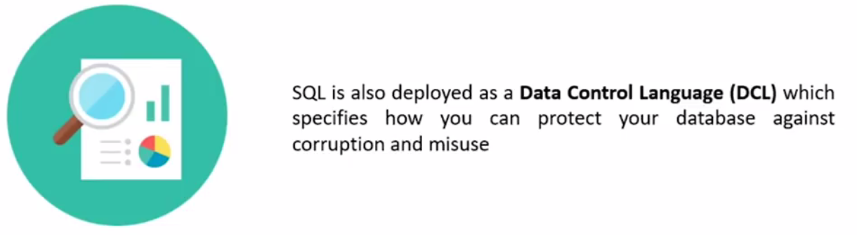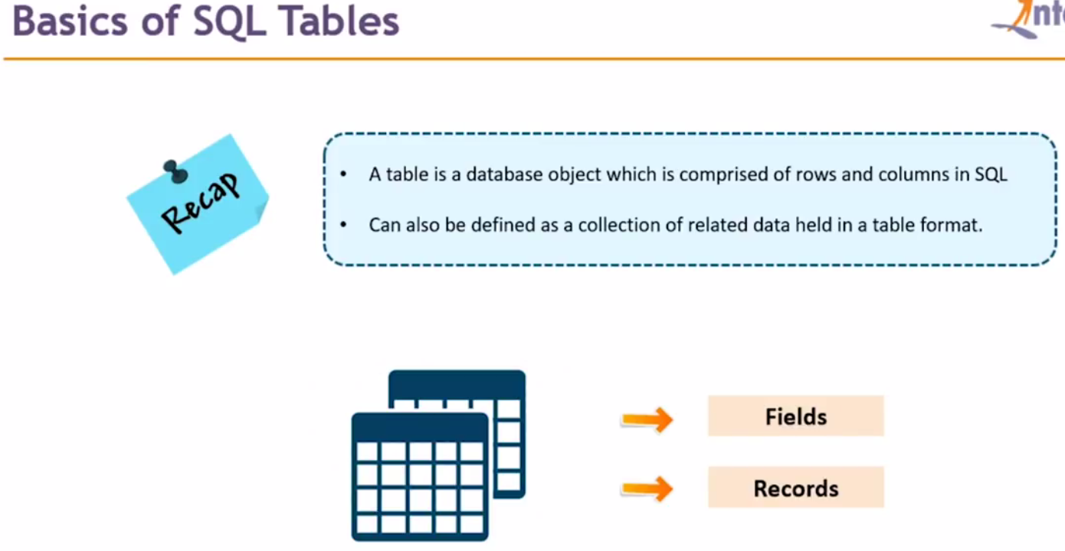

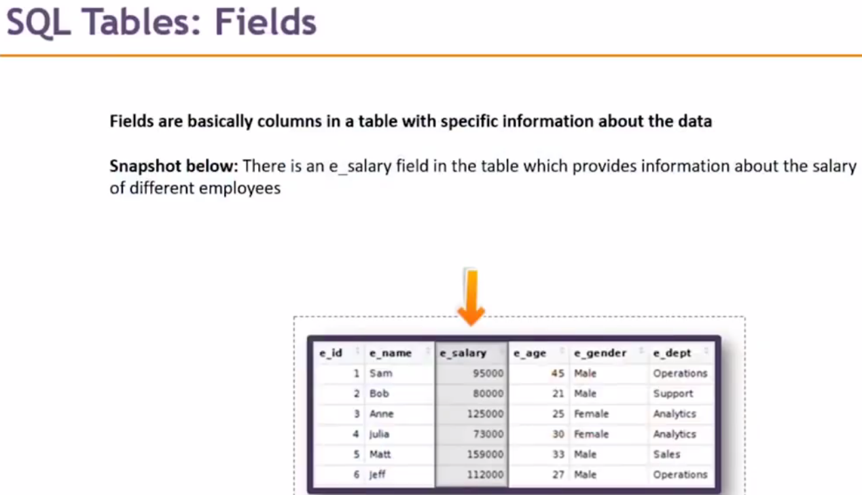

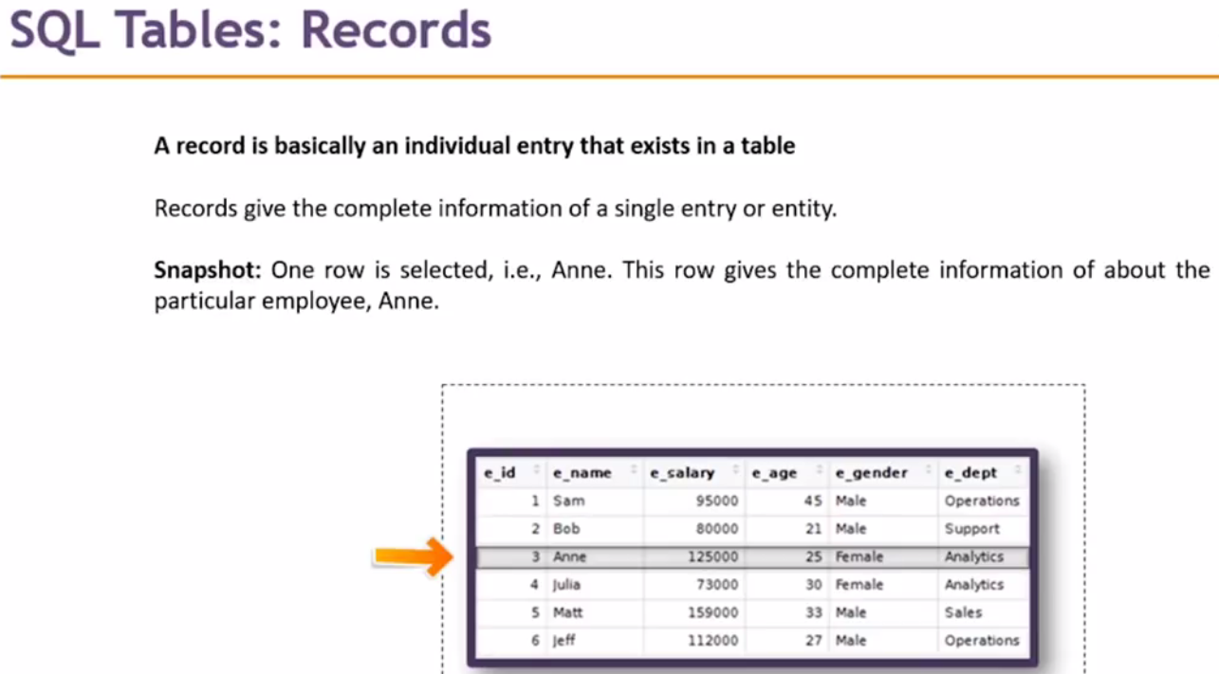

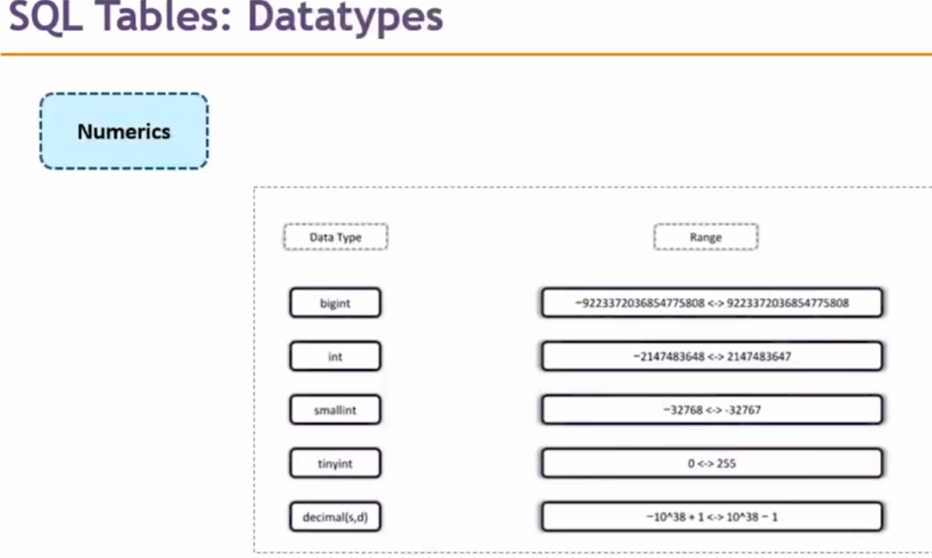

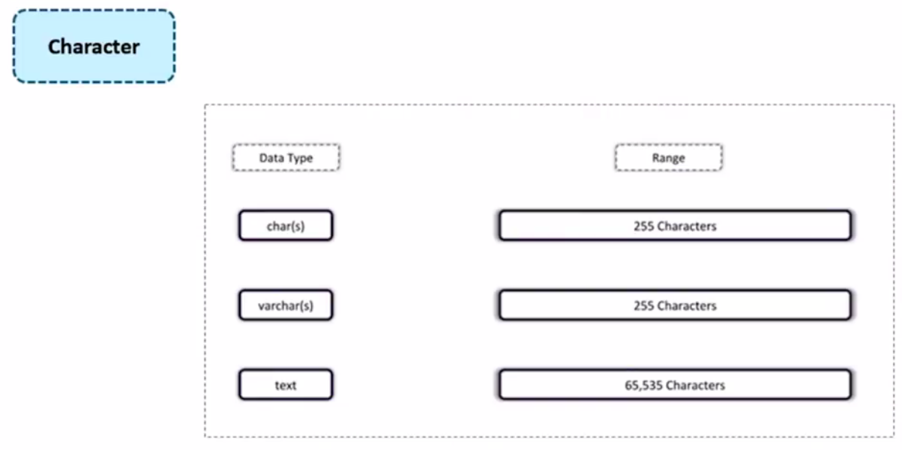

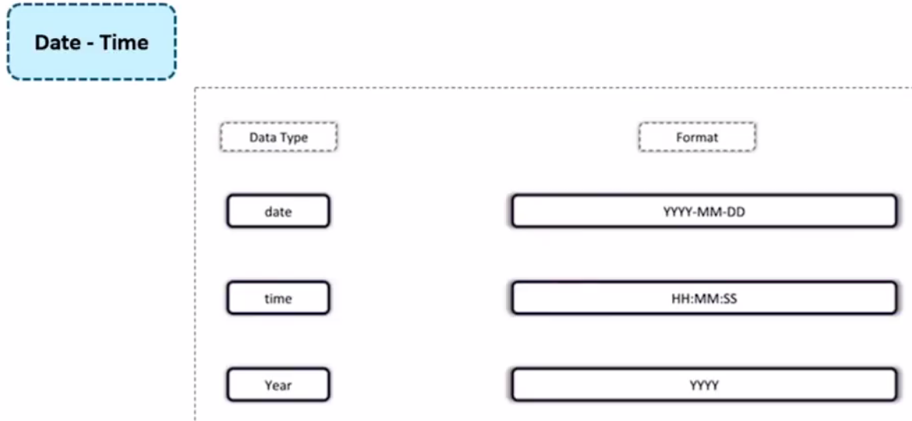

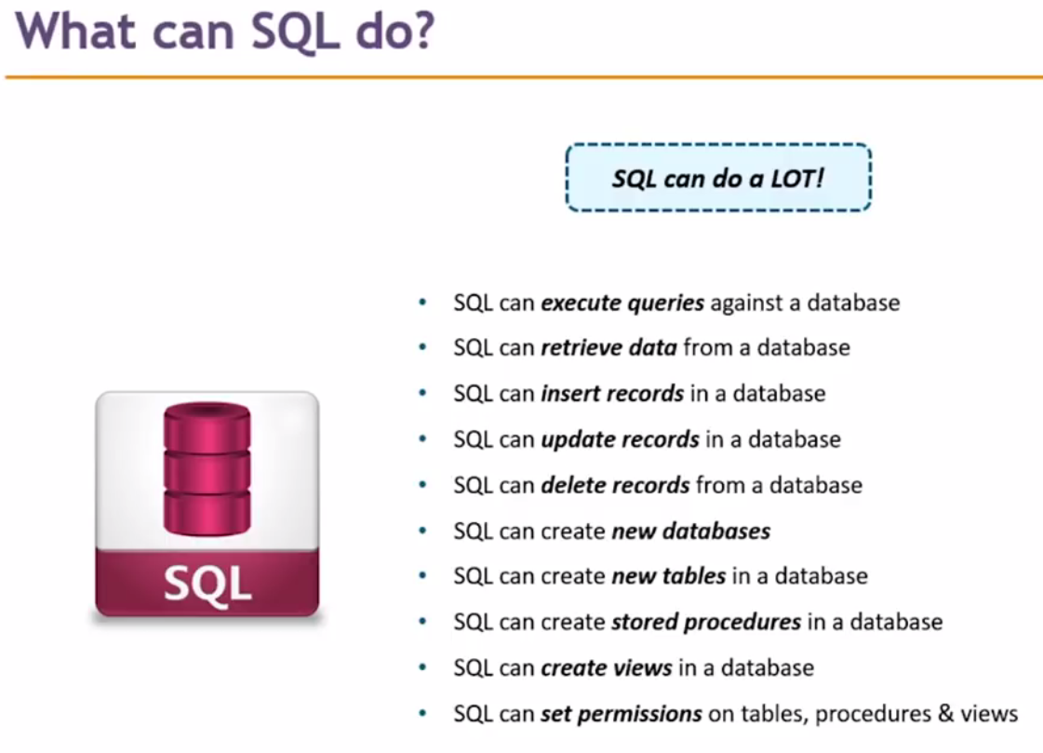

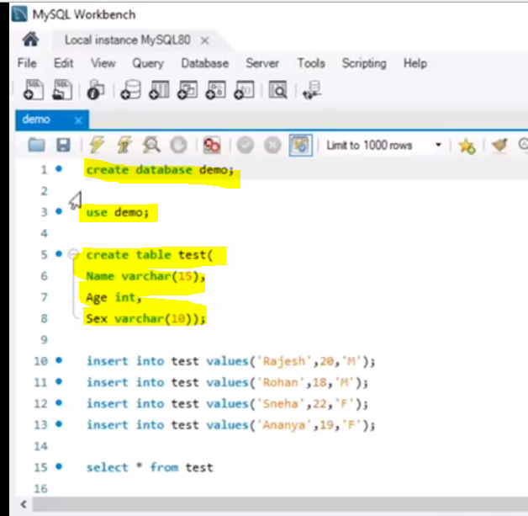

1. First create database
2. Then use the same database
3. Create table into the same database
4. Now finally insert the record into table

|  |  |
| --- | --- |
|  | It will delete record from table test whose name = Rohan  Will drop the database itself having tables and record. |

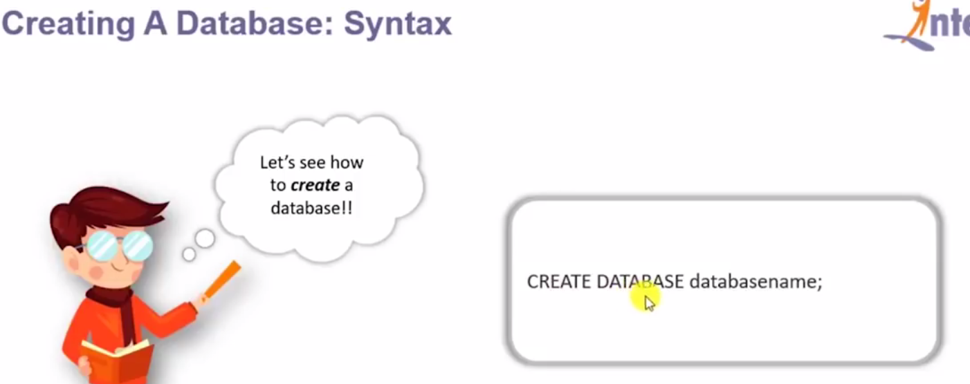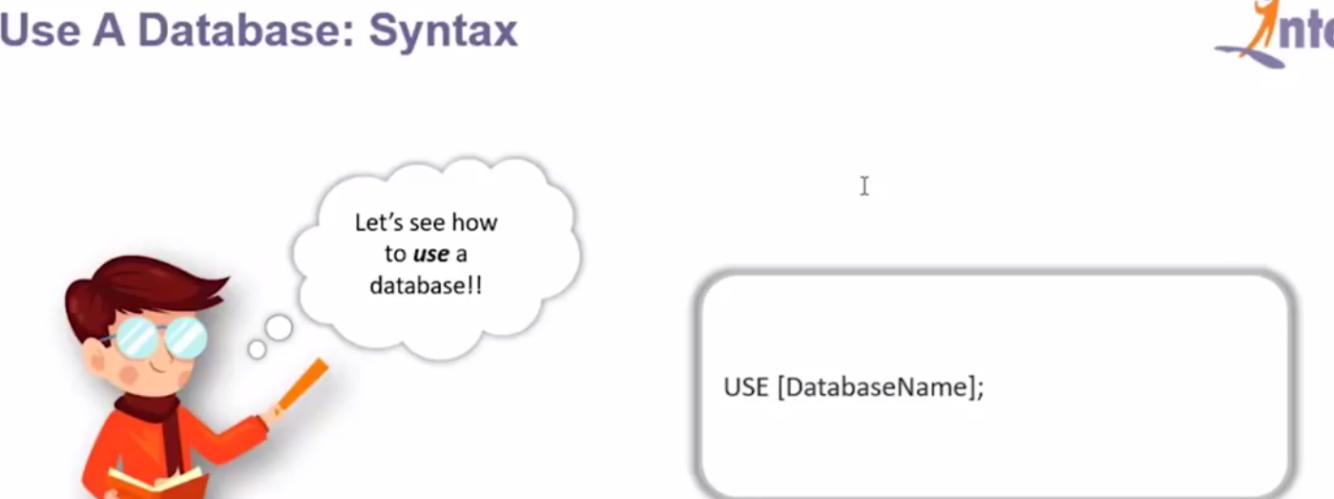

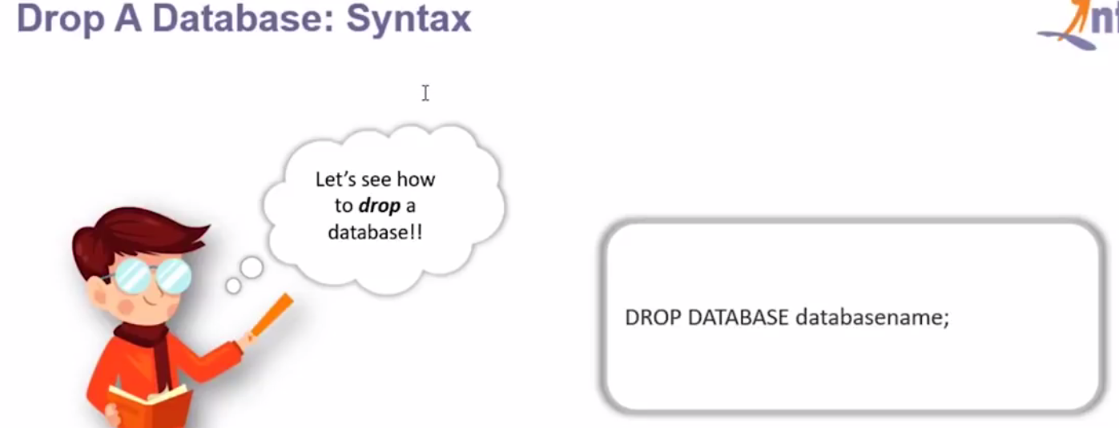

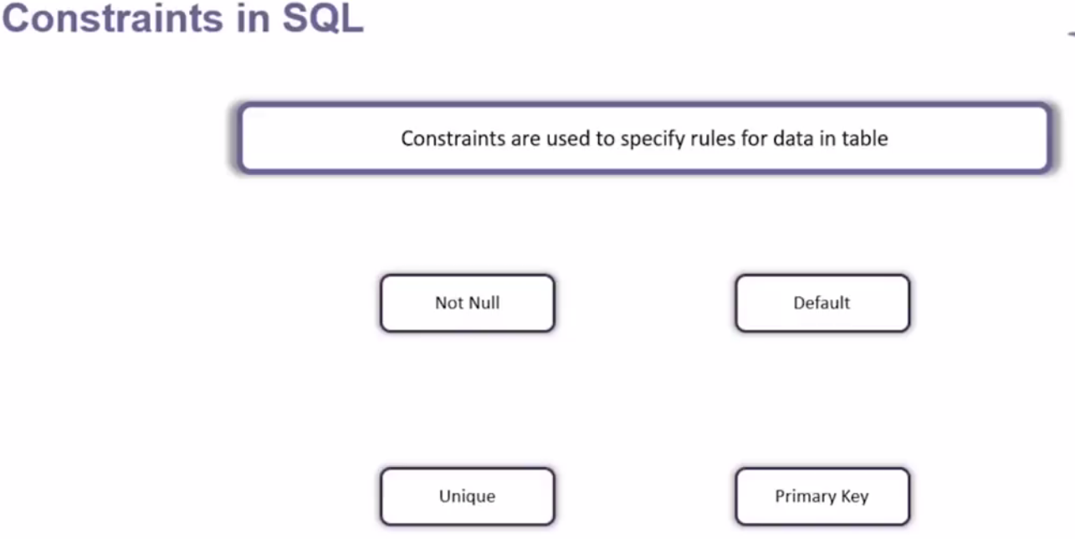

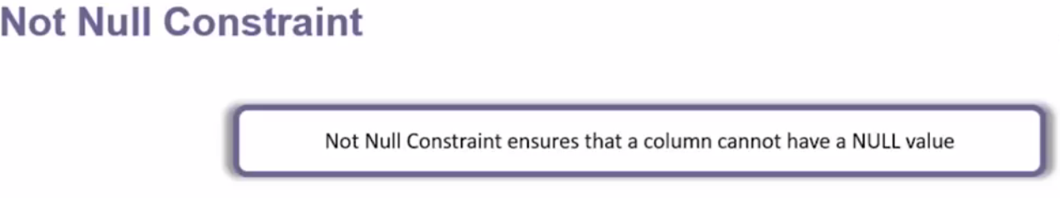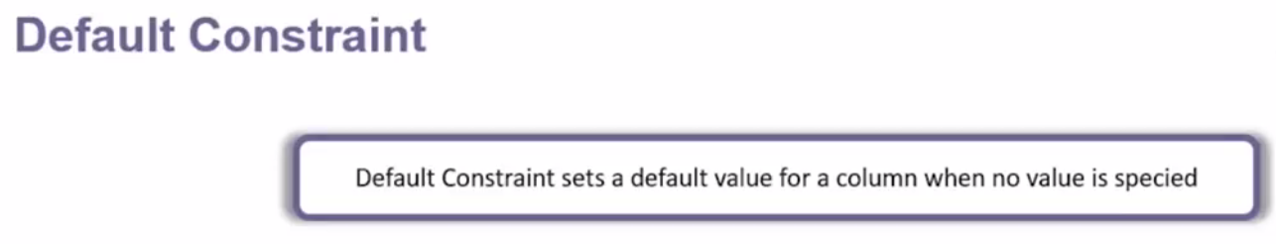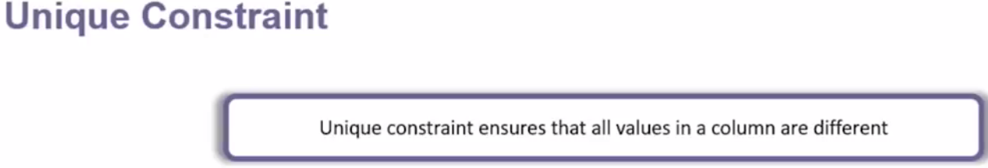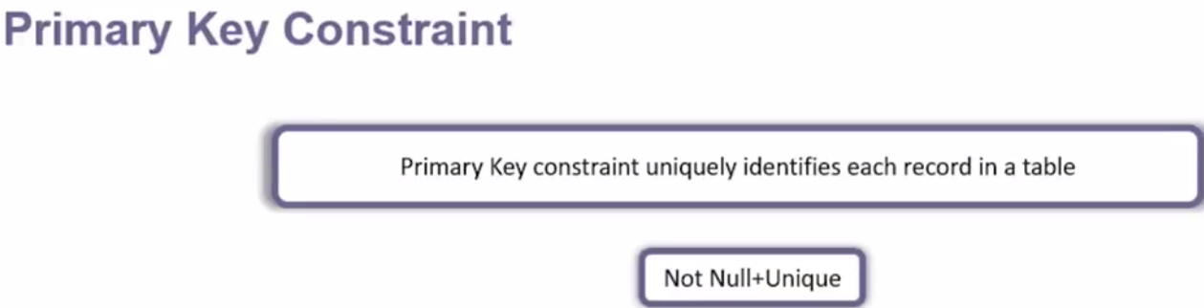

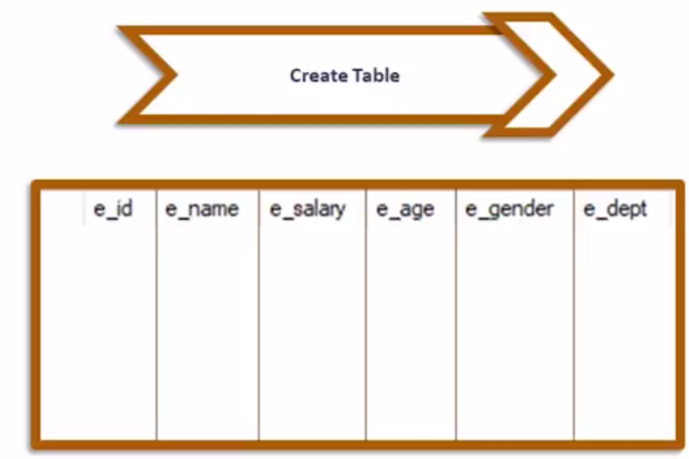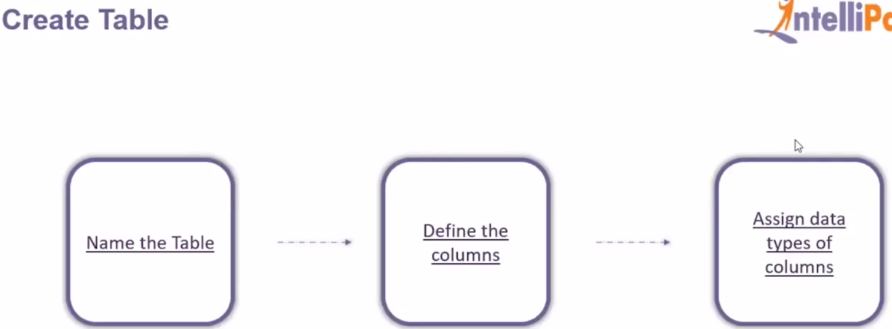

|  |  |
| --- | --- |
|  |  |

|  |  |
| --- | --- |
|  |  |

|  |  |
| --- | --- |
|  |  |
|  |  |

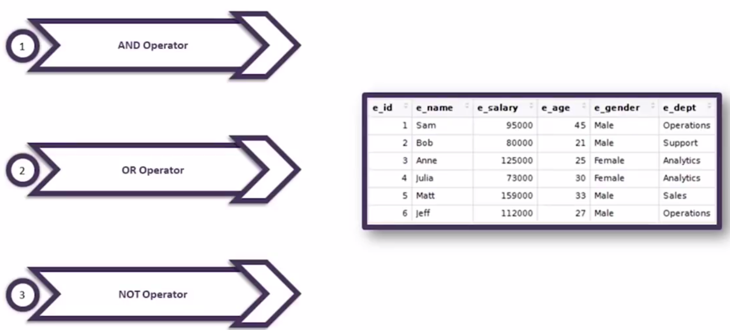

|  |  |
| --- | --- |
|  |  |





|  |  |
| --- | --- |
|  |  |



|  |  |
| --- | --- |
|  |  |



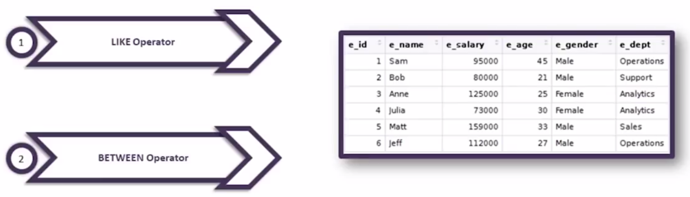

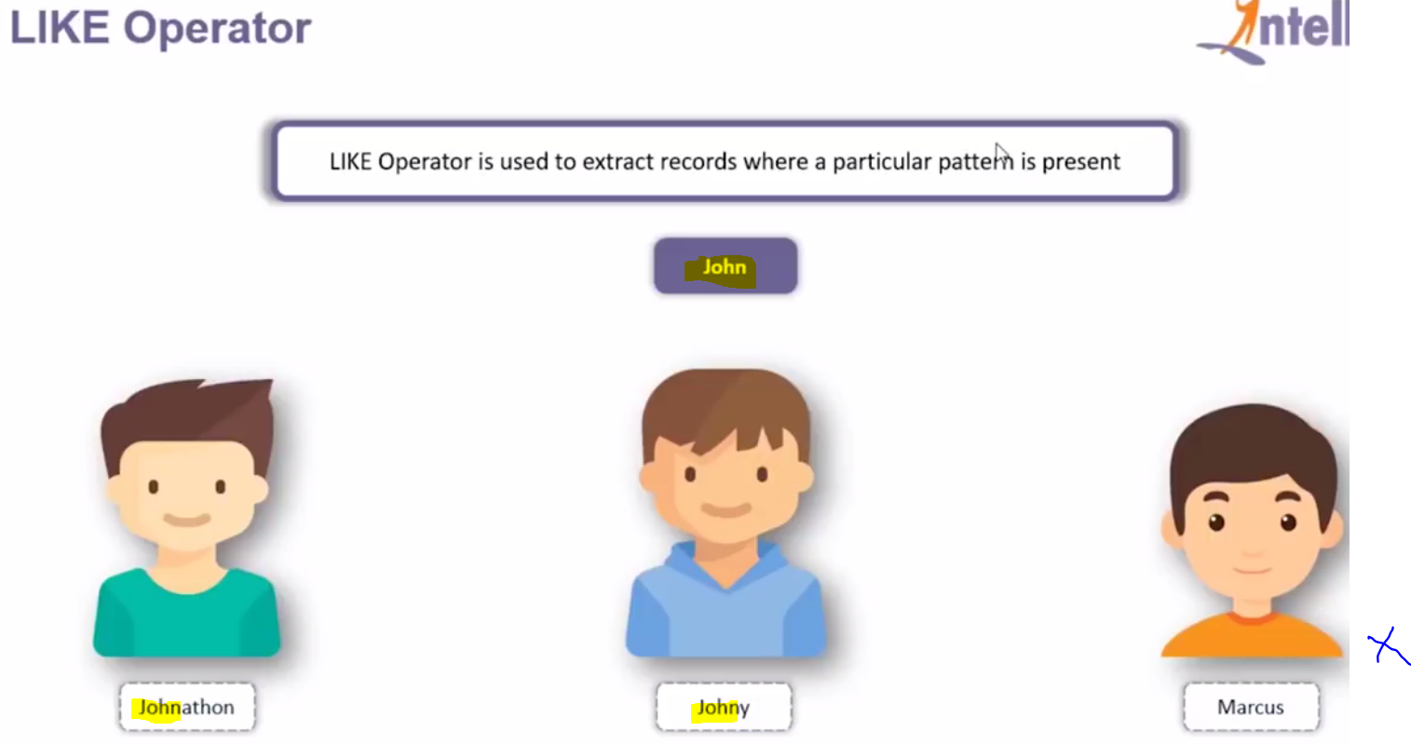

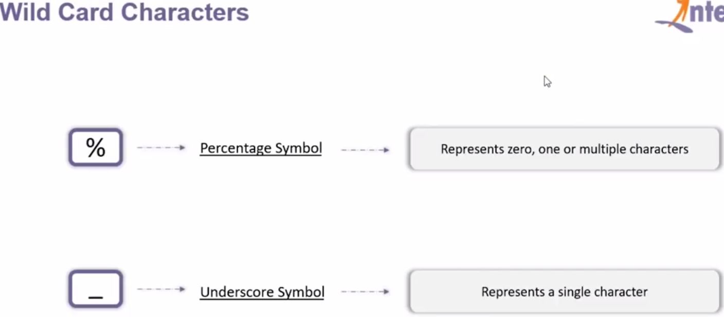



Display all the employees whose name starts from j.



Displays whose age starts from 30

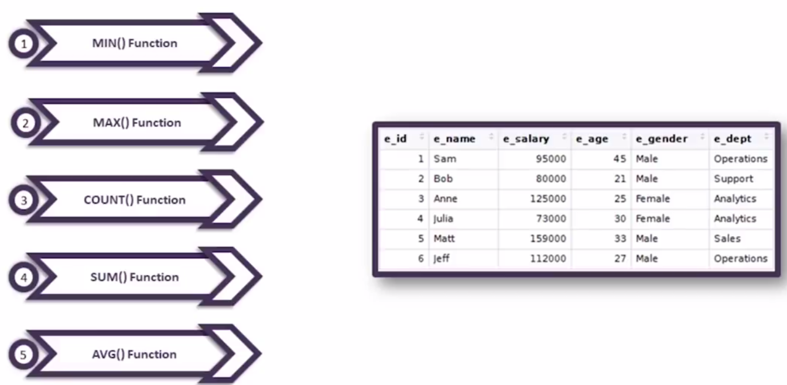

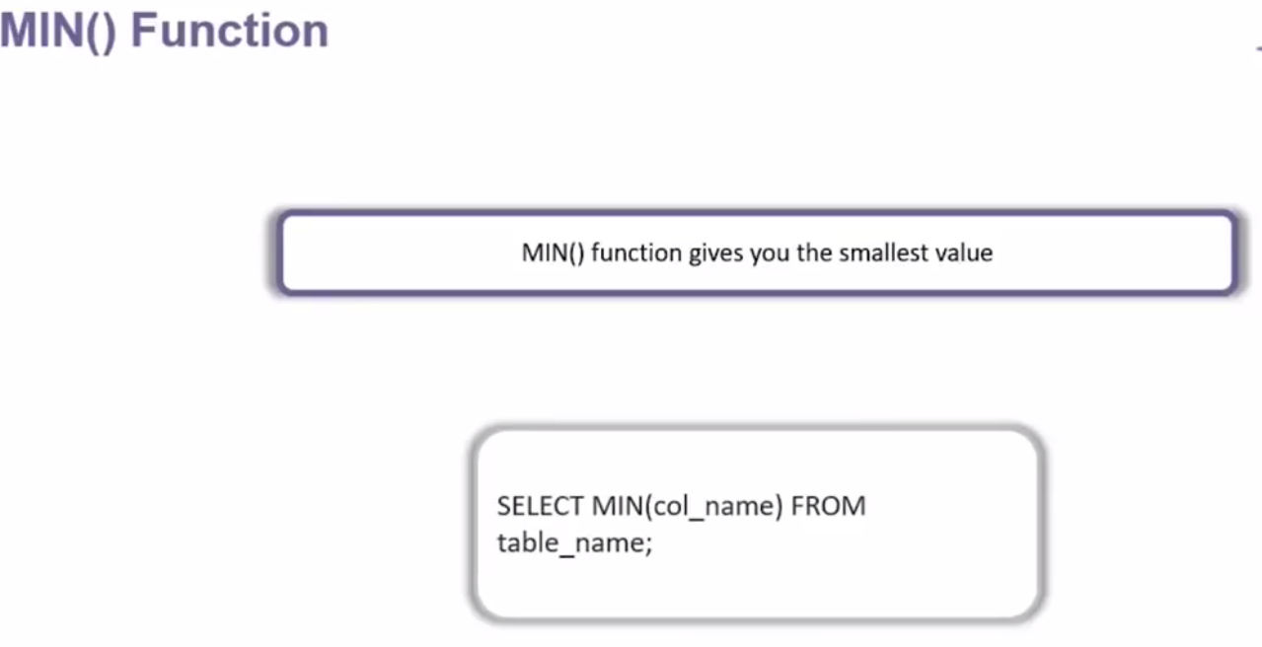

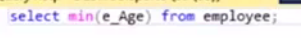

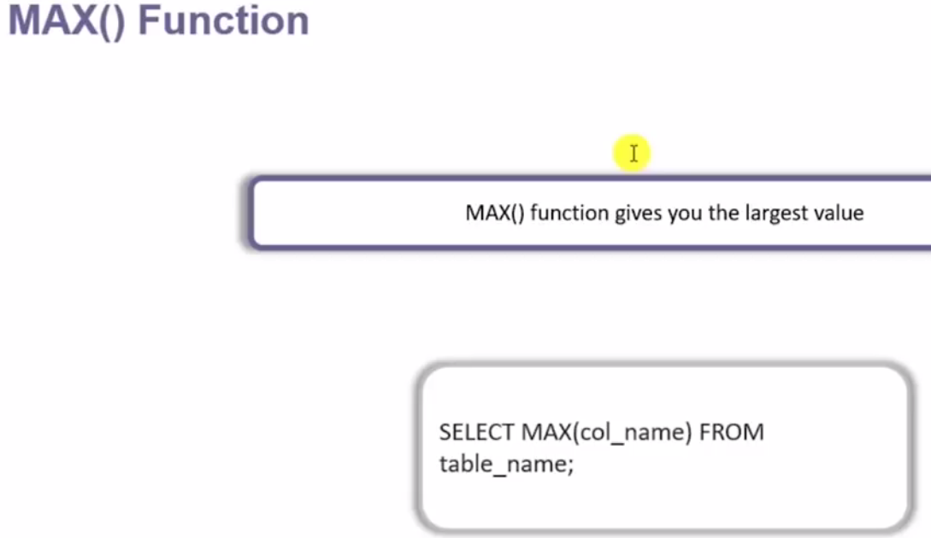



|  |  |
| --- | --- |
|  |  |



Return the count of male

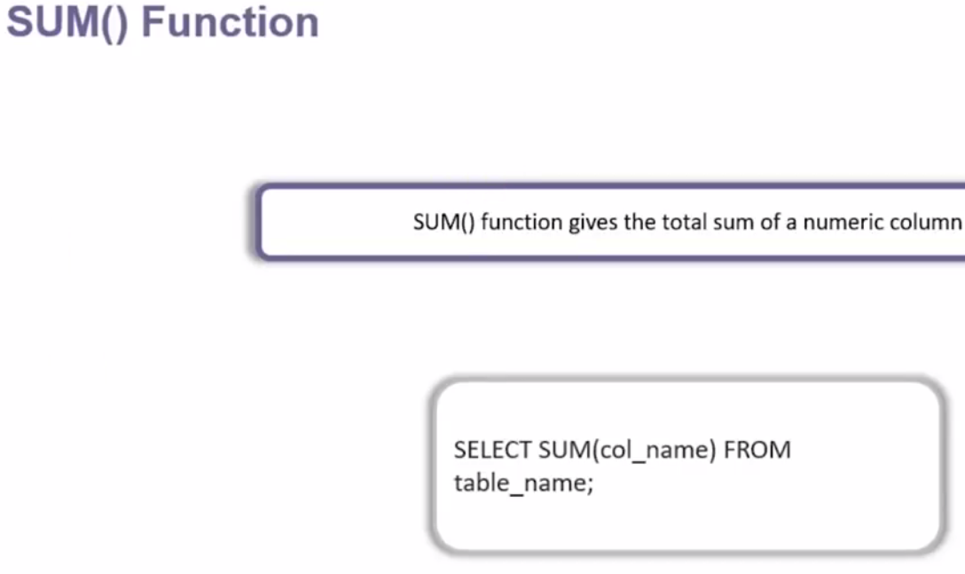

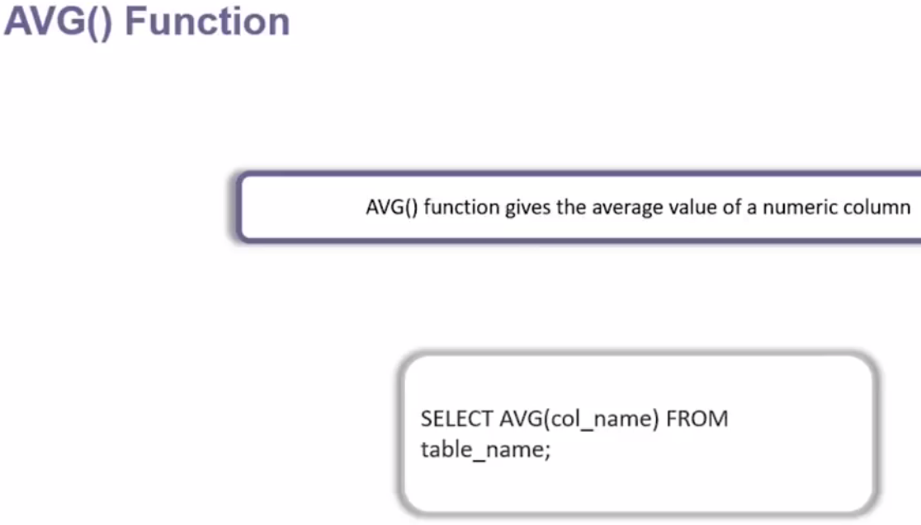





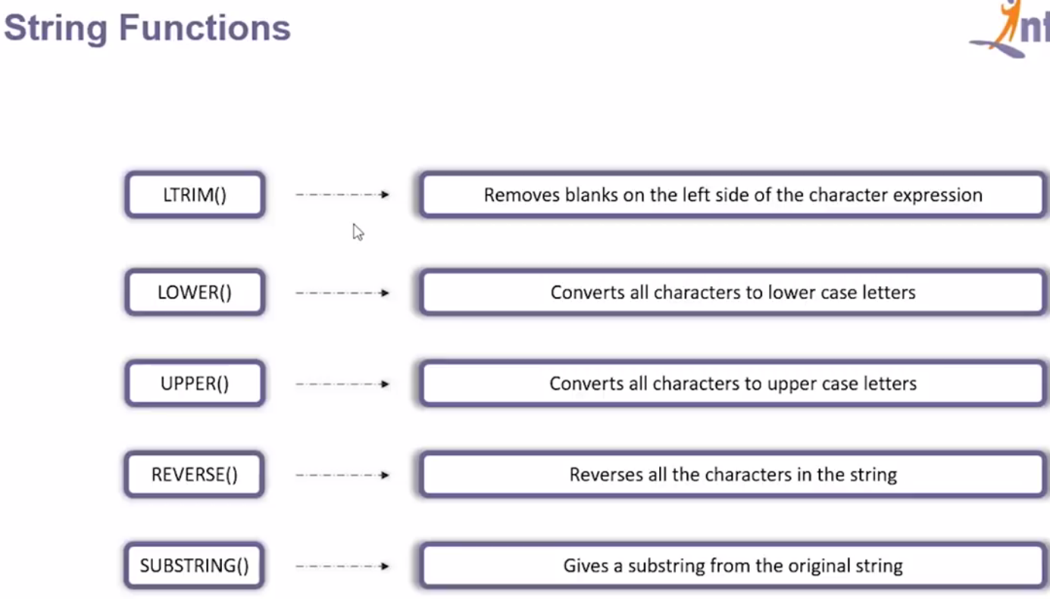

|  |  |
| --- | --- |
|  |  |

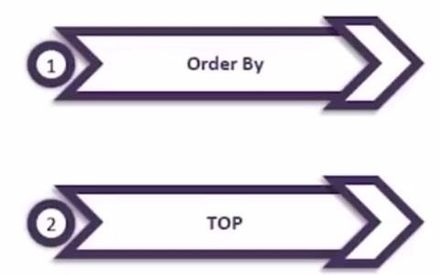

|  |  |
| --- | --- |
|  |  |



 OR Limit clause (used in MySql)



|  |  |
| --- | --- |
| Example: |  |

In case of MySql we will have use limit

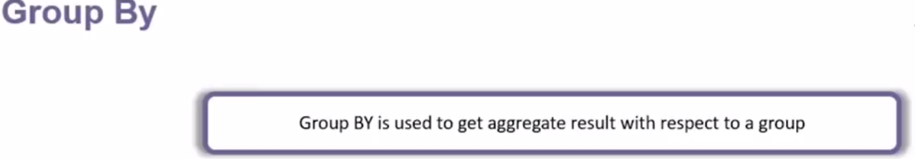

|  |  |
| --- | --- |
|  |  |



It gives the avarage salary group by gender wise.

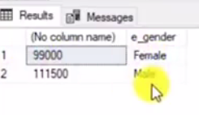  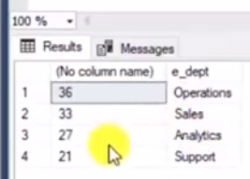

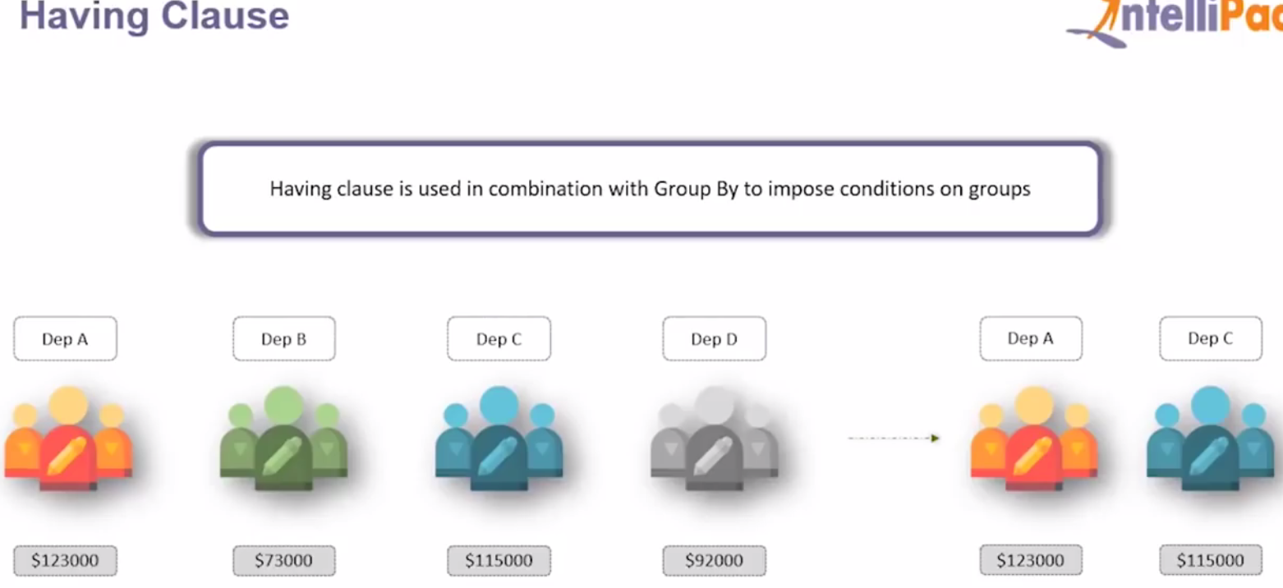 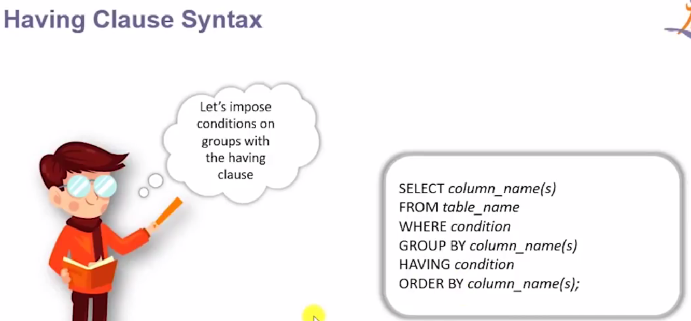

Note: Having cluse must be used followed by Group By and Order By and cannot used with where clause.

|  |  |
| --- | --- |
|  |  |

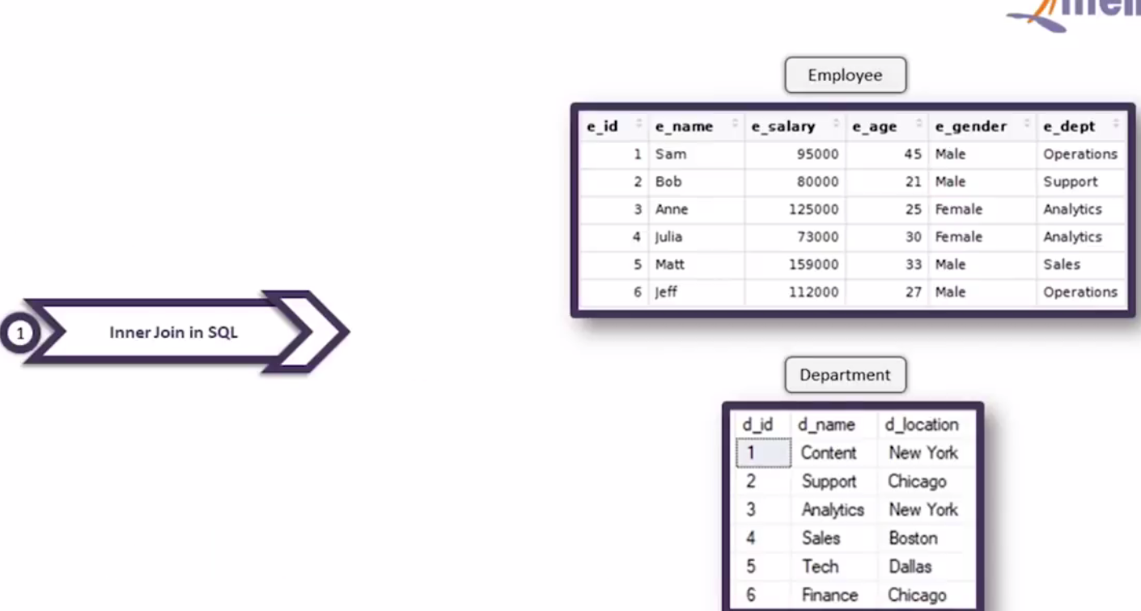

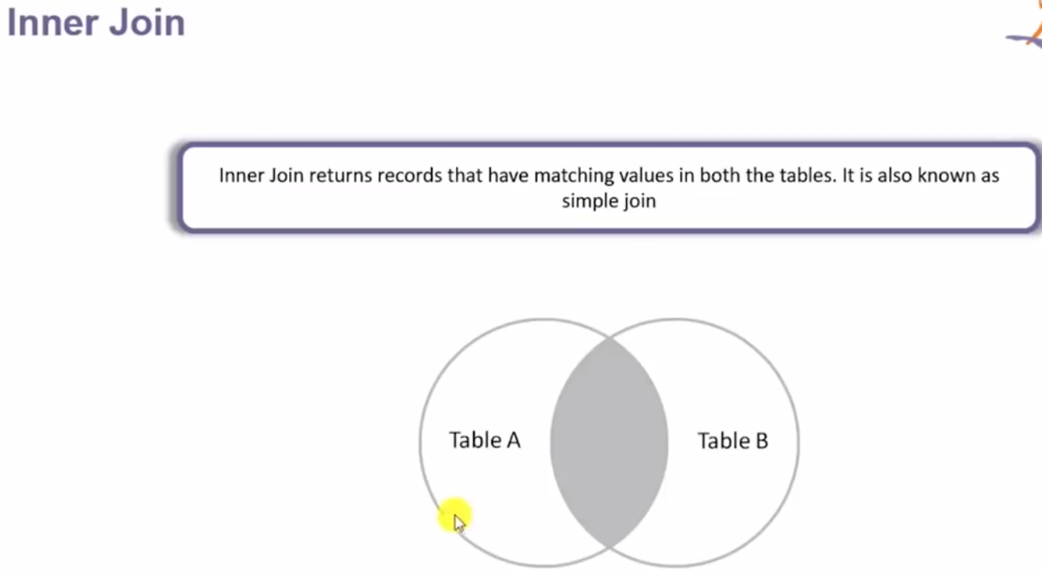

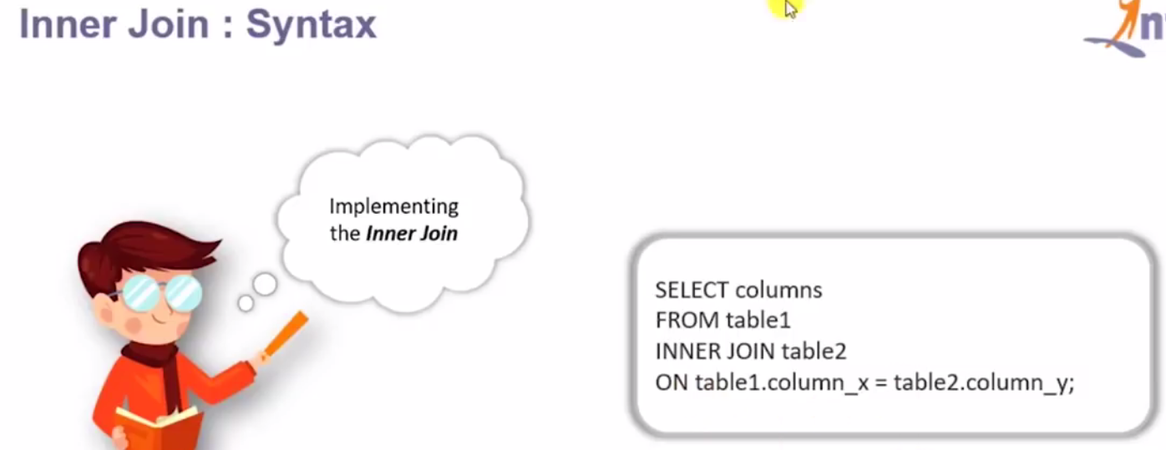

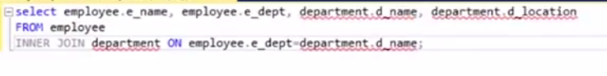 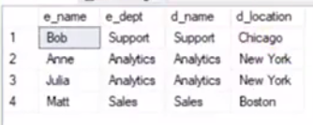

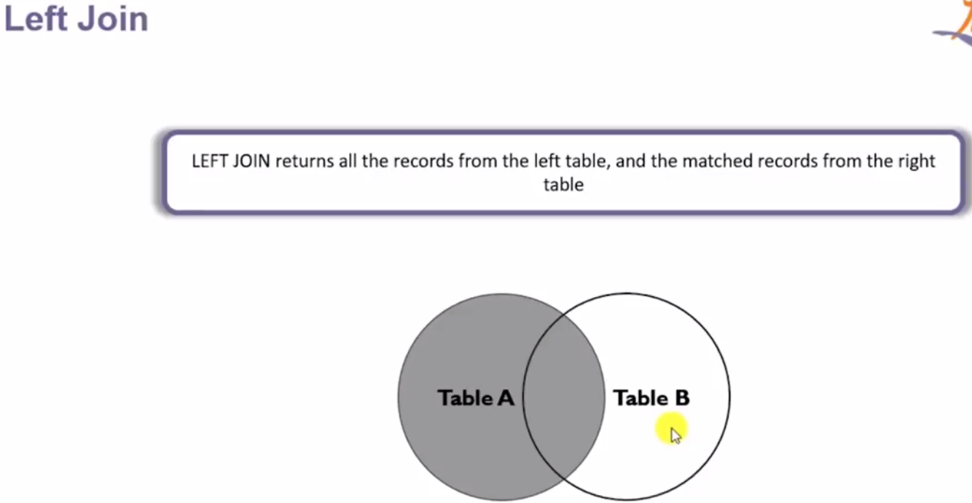

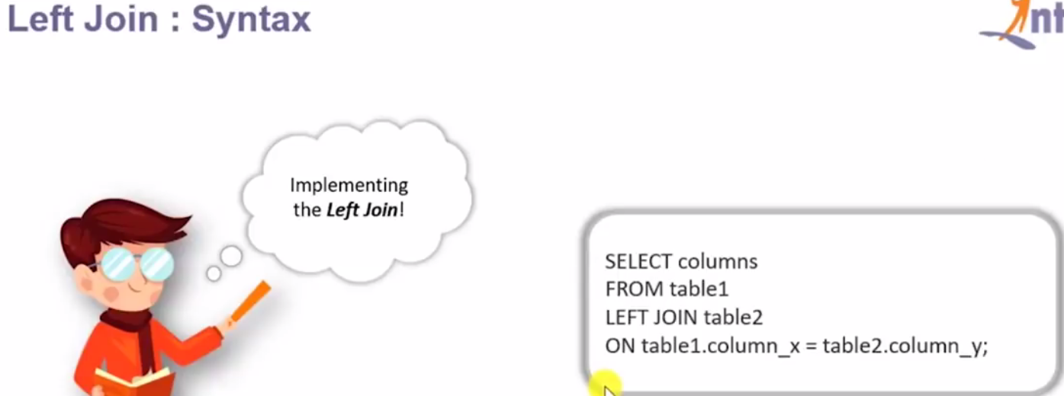

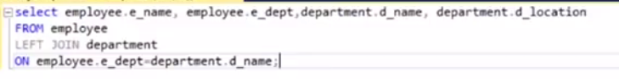 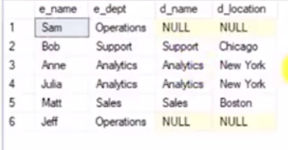

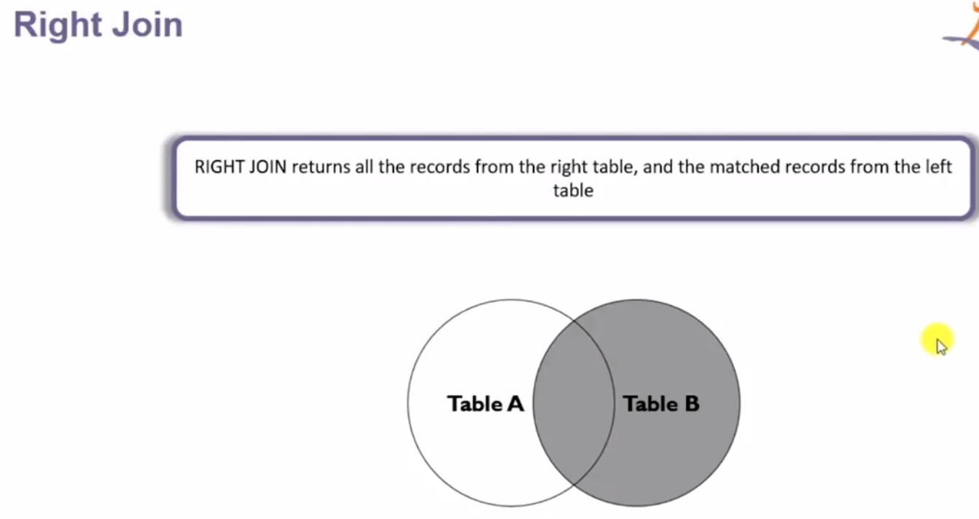

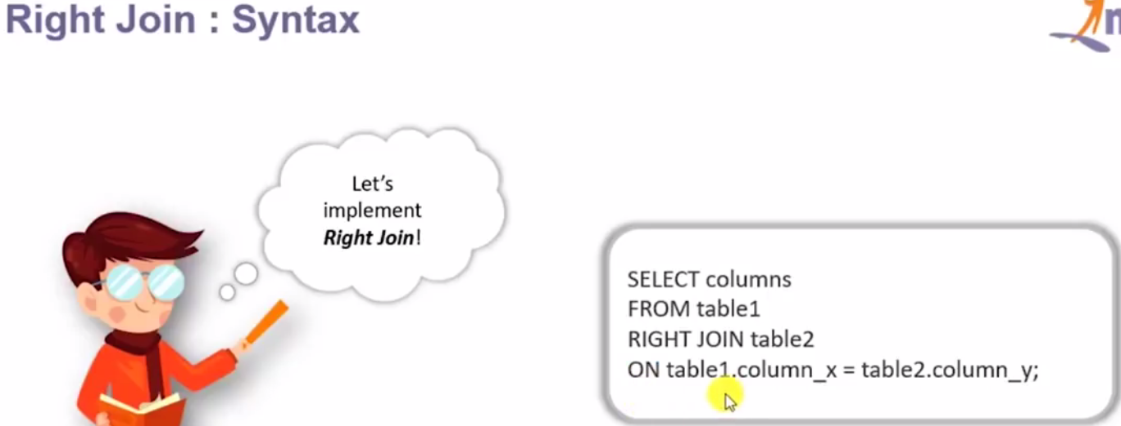

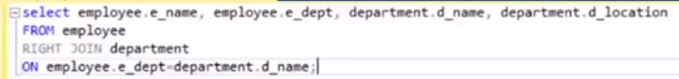

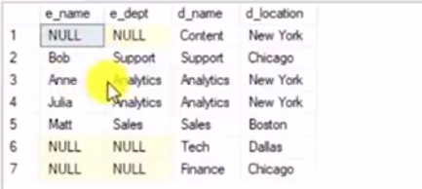

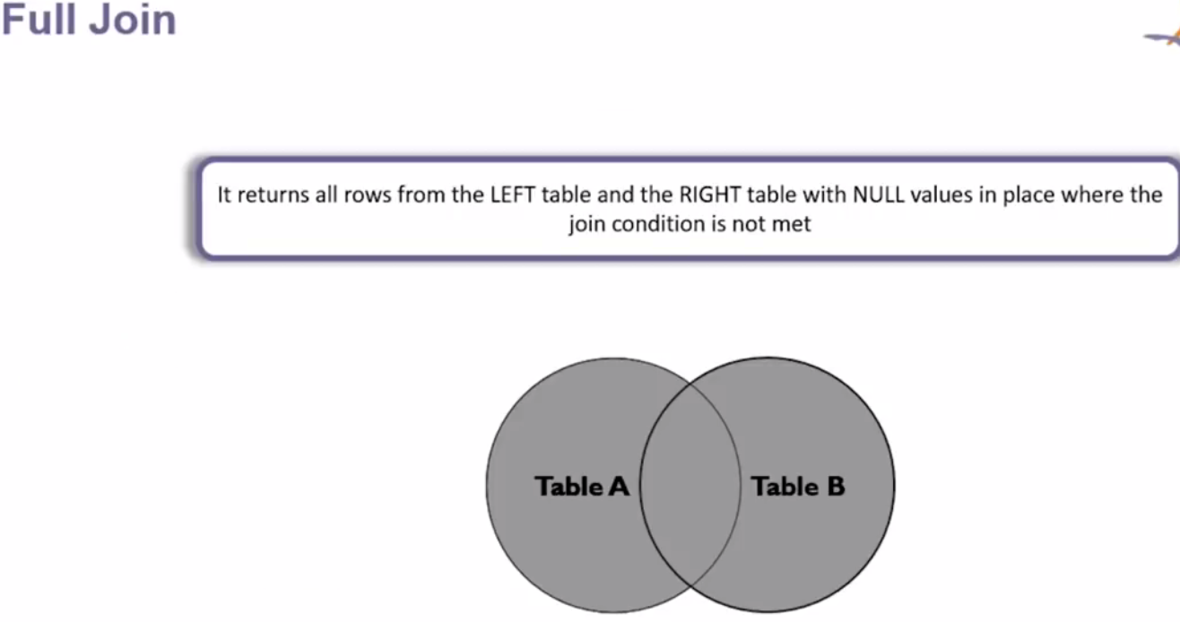

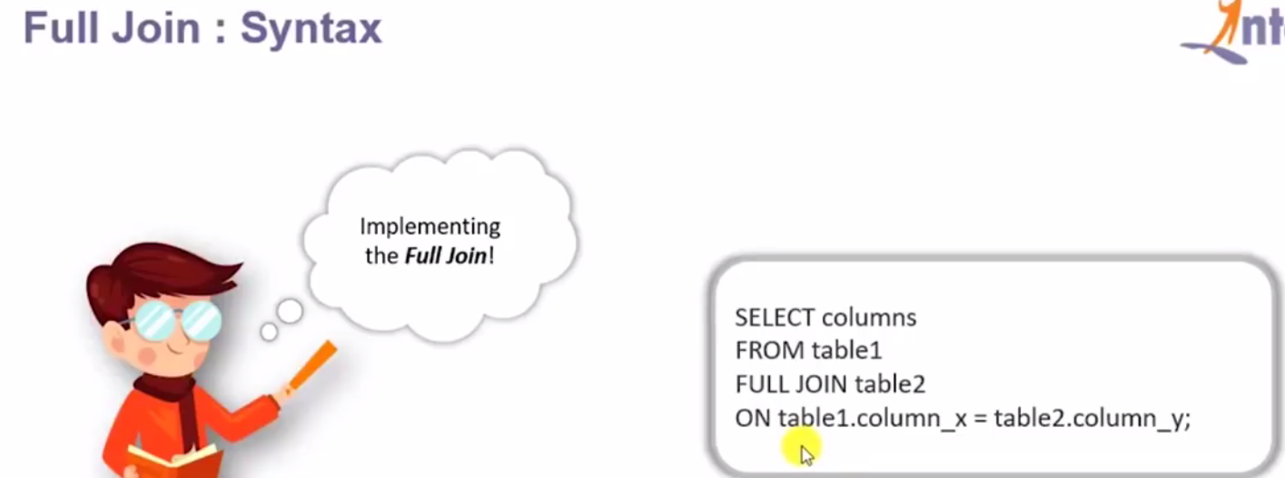

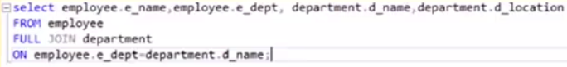 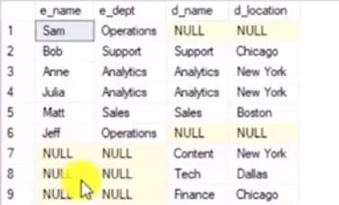

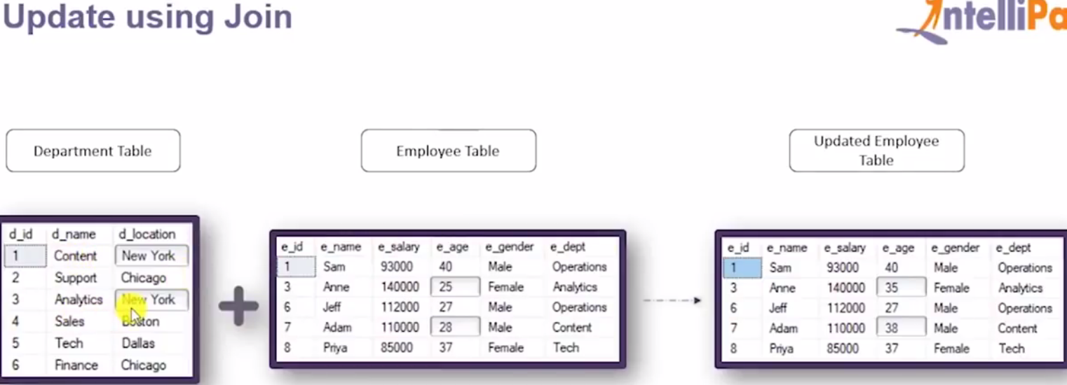

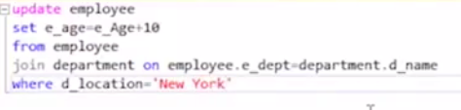

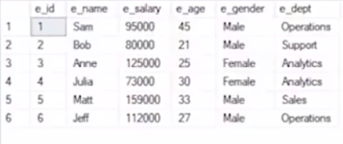 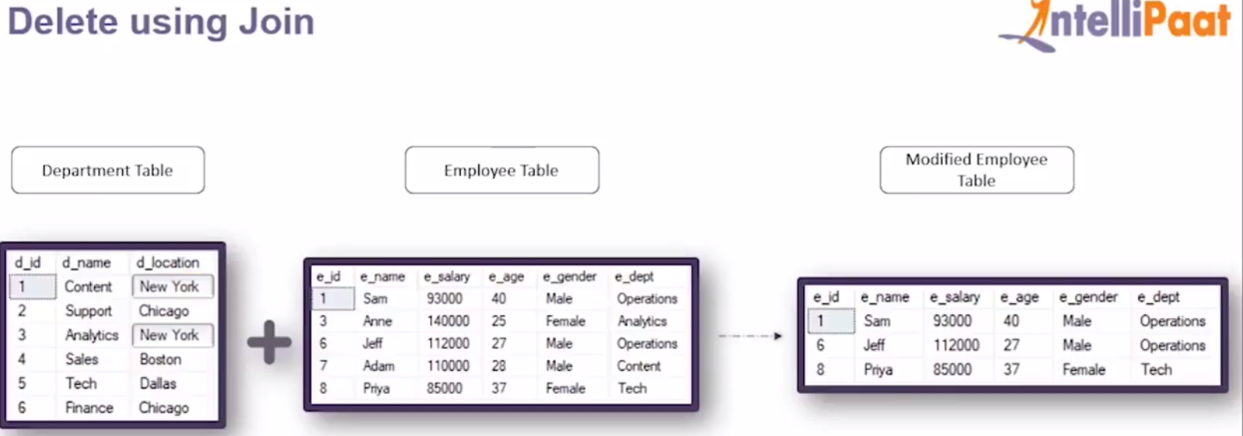

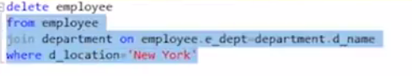

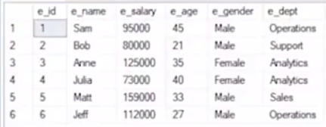

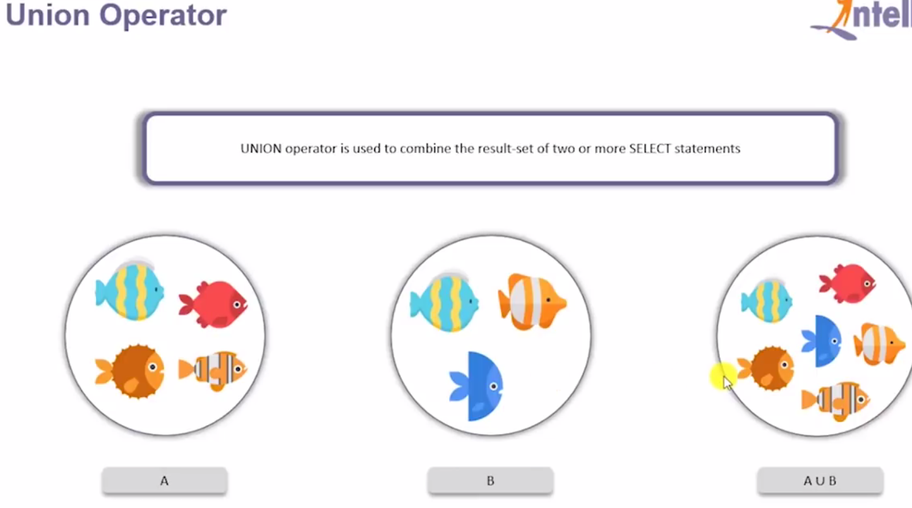

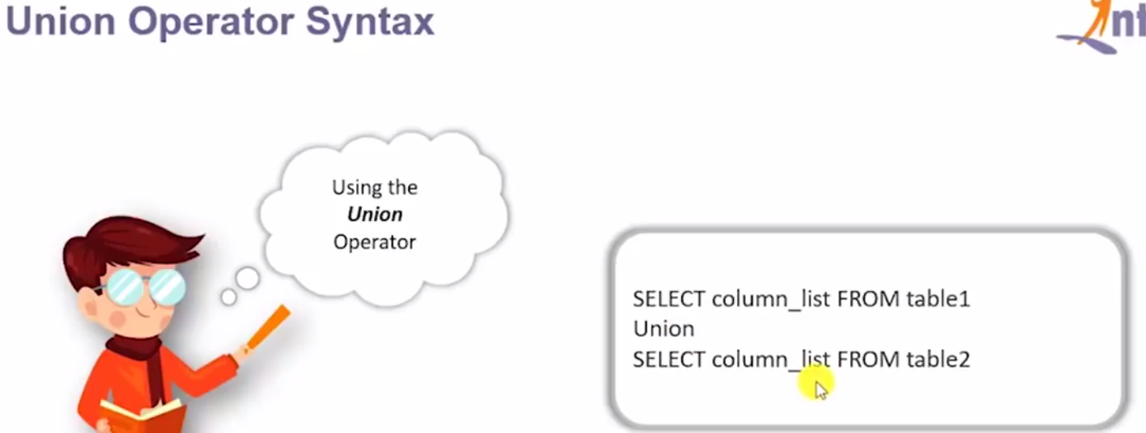

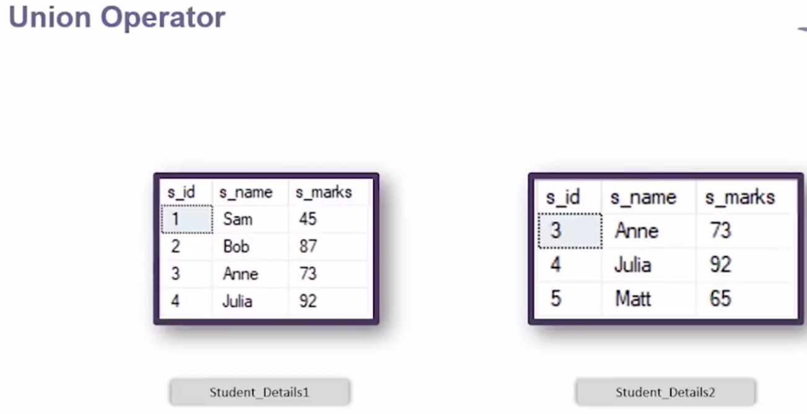

|  |  |
| --- | --- |
|  |  |

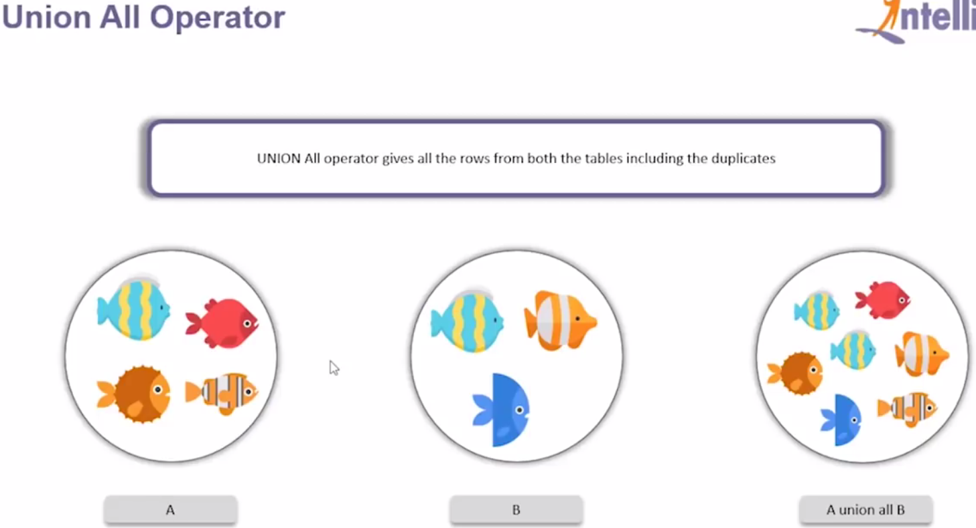

|  |  |
| --- | --- |
|  |  |

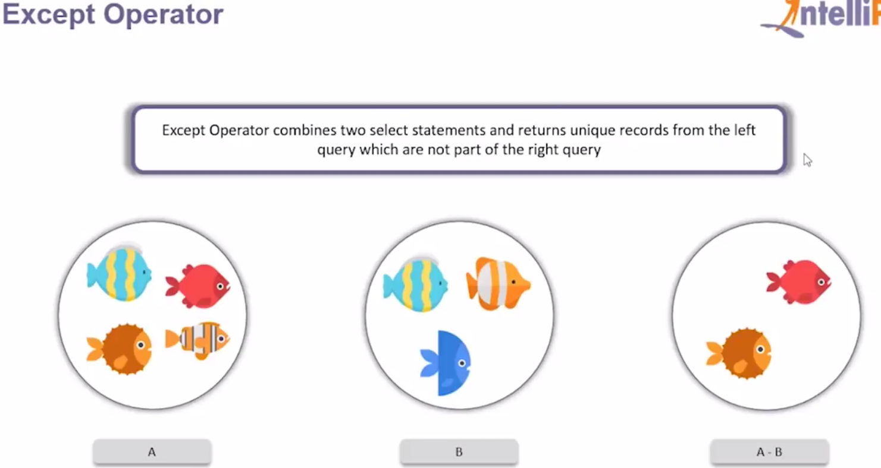

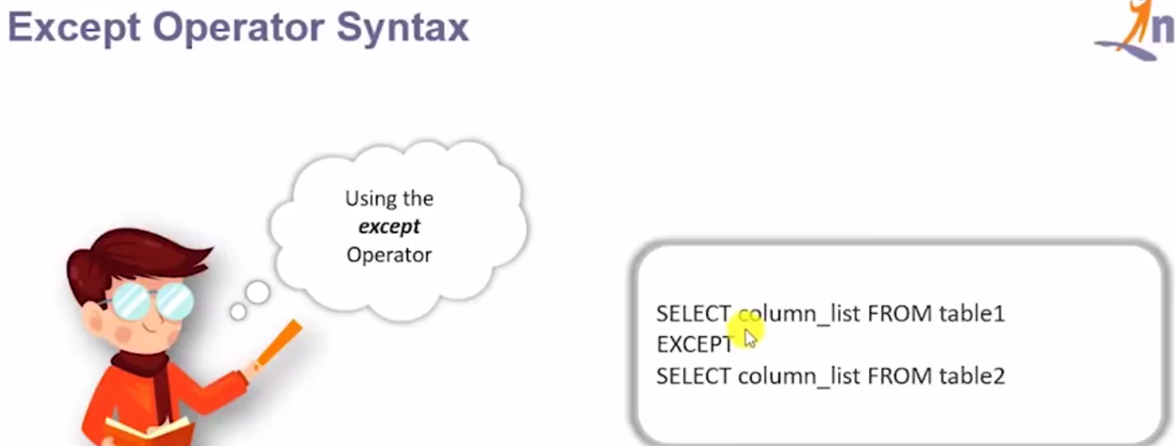

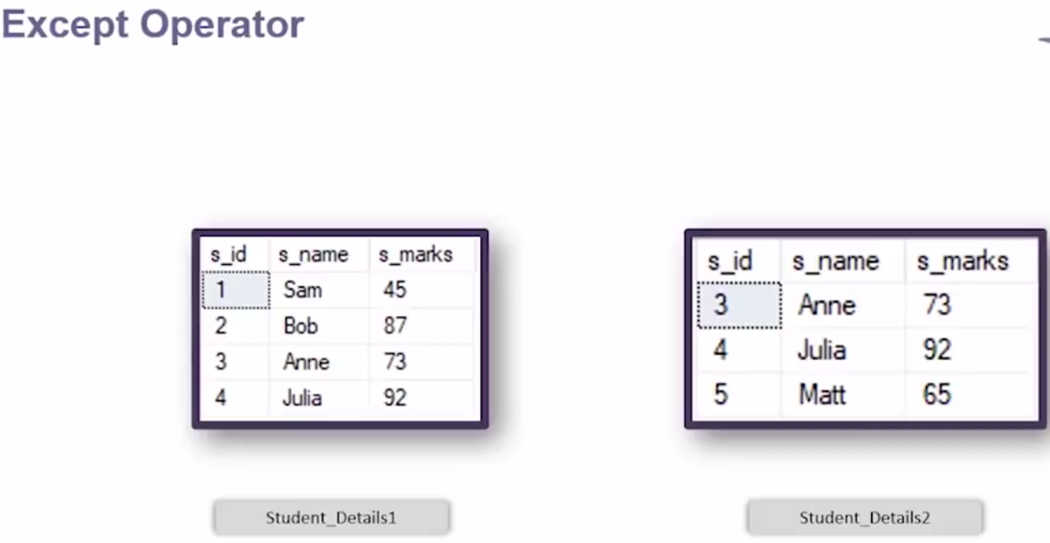

|  |  |
| --- | --- |
|  |  |

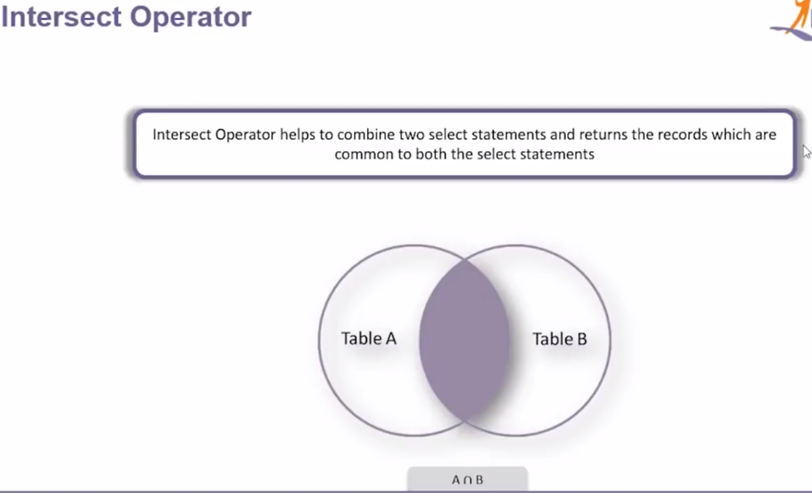 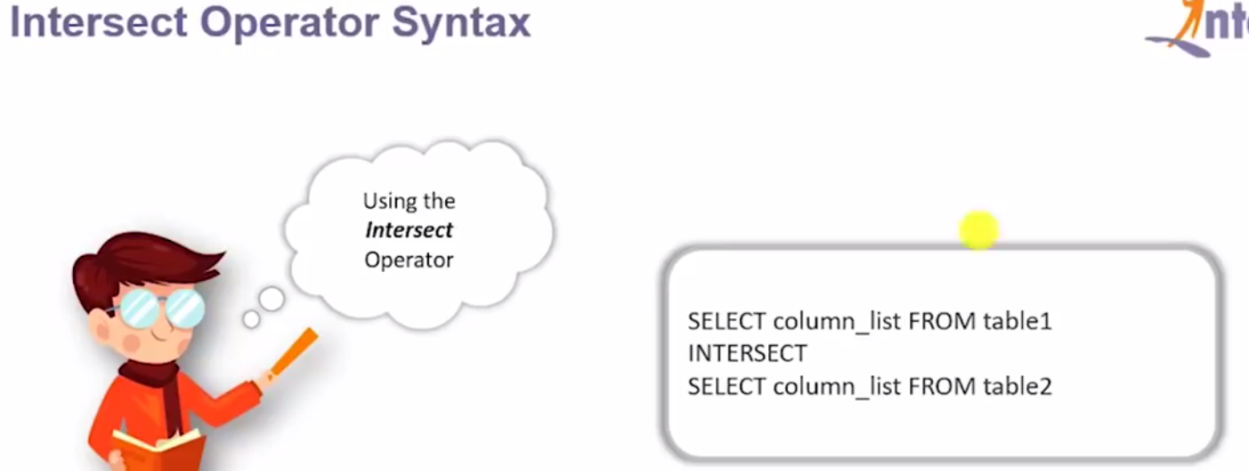

|  |  |
| --- | --- |
|  |  |

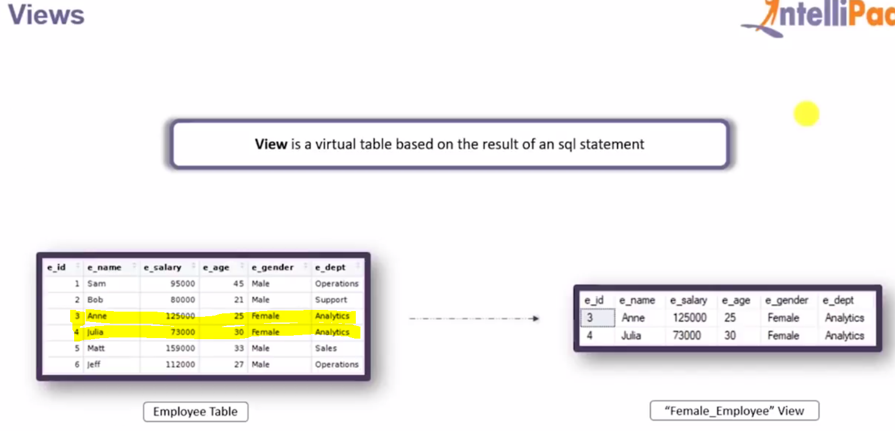

View Is used to limit the record in order to display and it is nothing but the sql statement only but have the name associated with it and same name we can reuse further any where instead of writing queries. 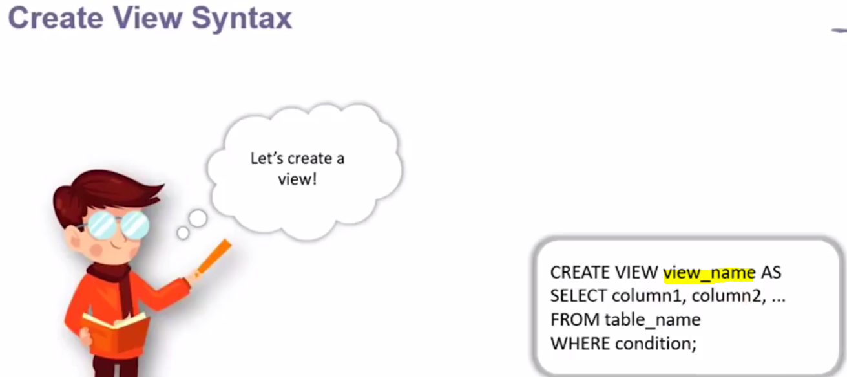

|  |  |
| --- | --- |
| Created view with name – female_employees |  |

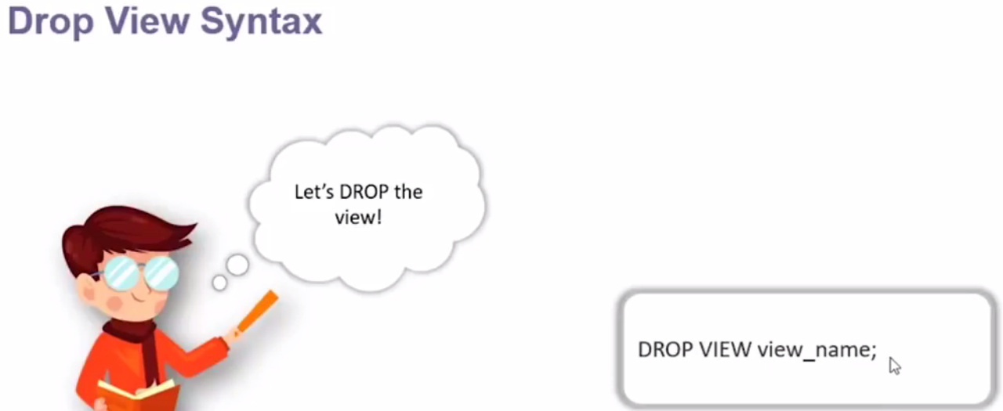

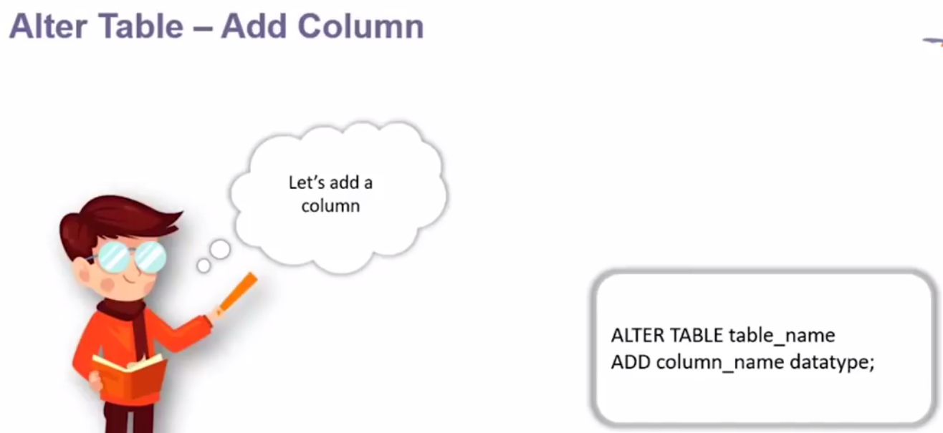

|  |  |
| --- | --- |
|  | New column e_dob added in the employee table and this way we can alter the existing table.  Example of below for dropping the column from existing table |

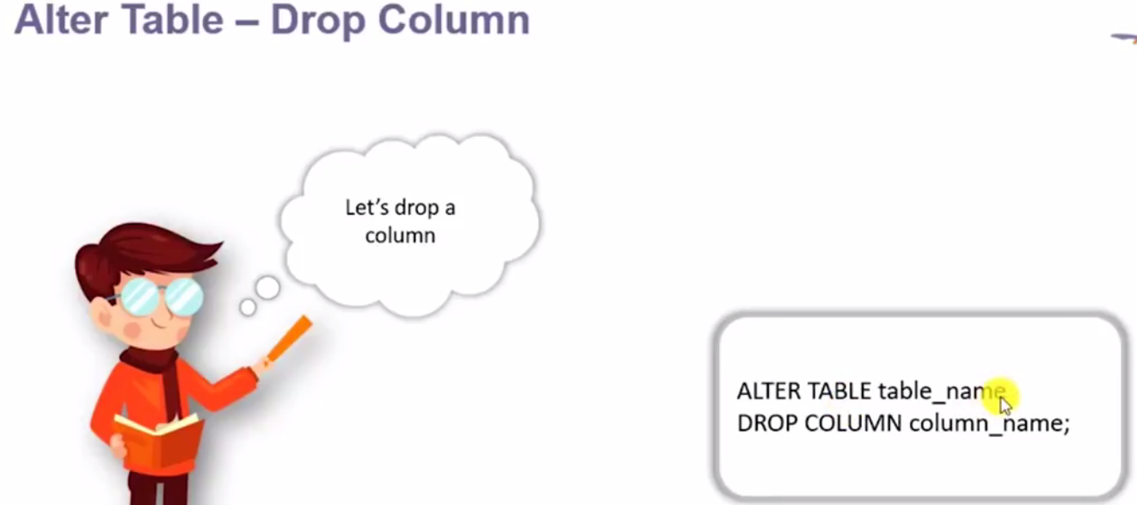

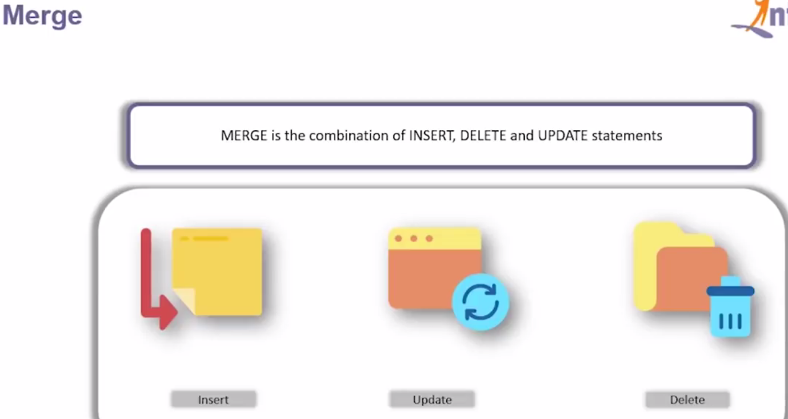

We required tables

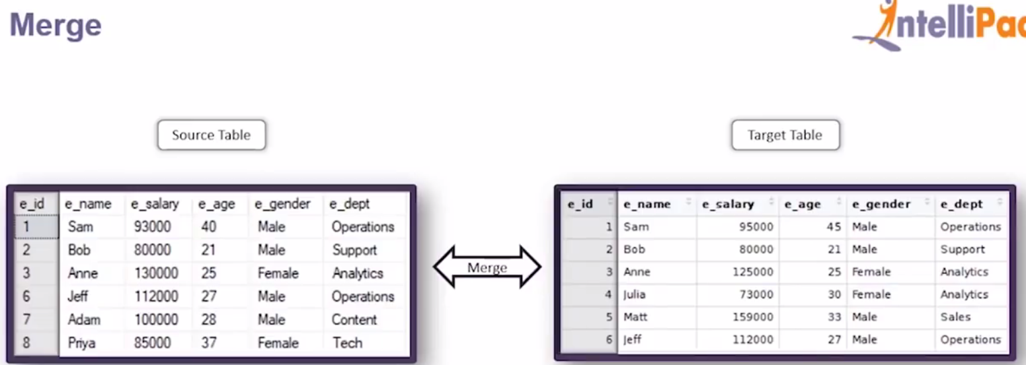

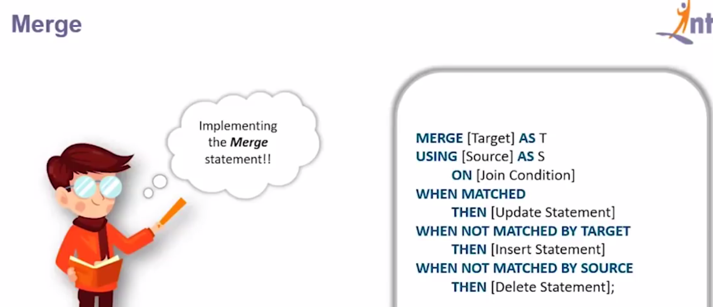

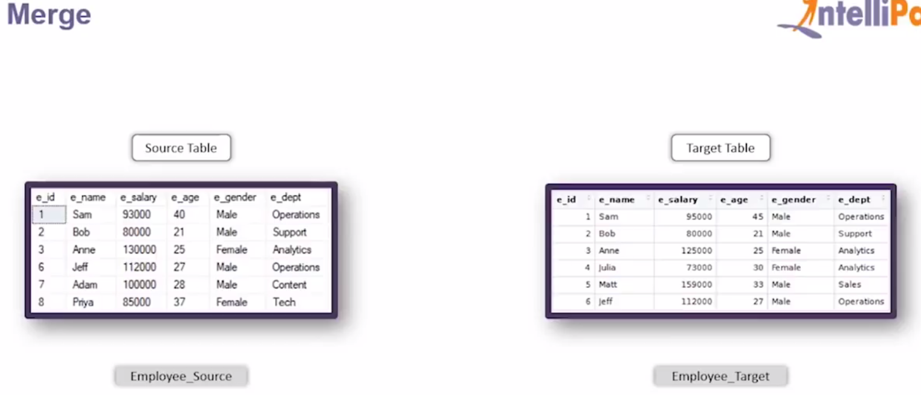

|  |  |
| --- | --- |
|  | After executing merge statement. |

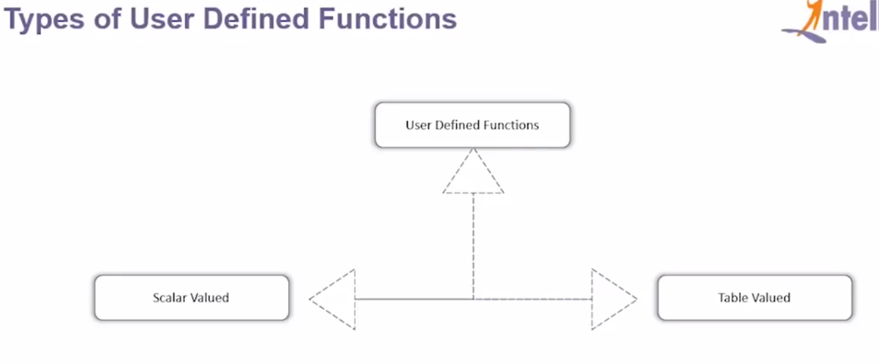

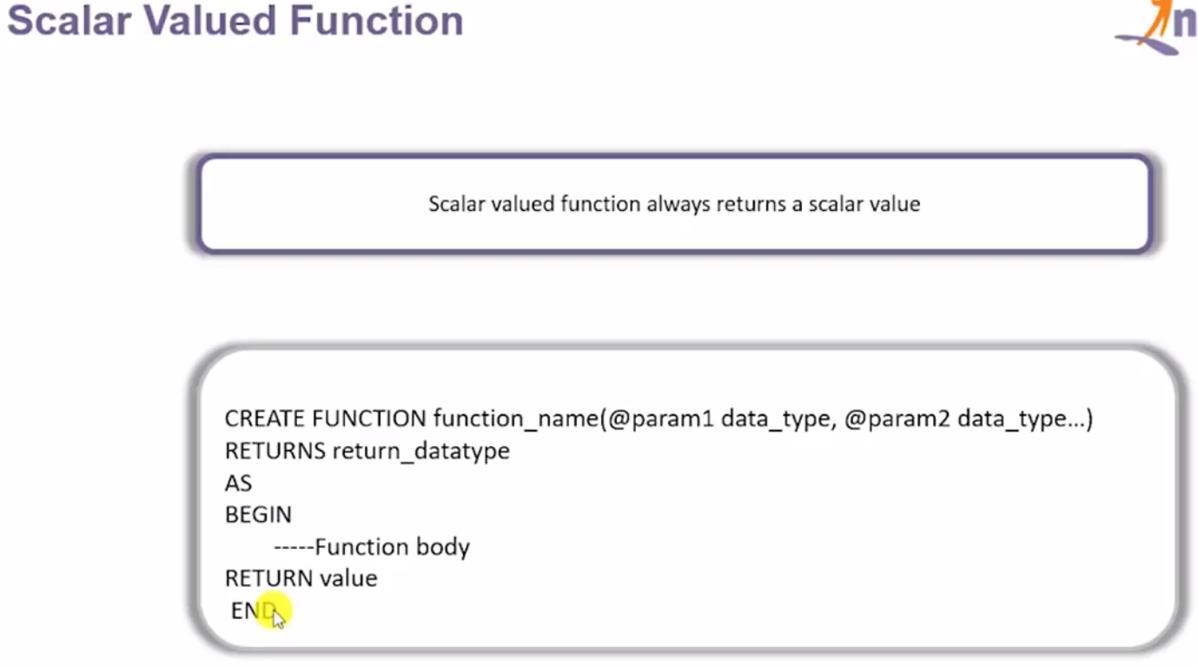

|  |  |
| --- | --- |
| Created a function with name add_five() and passing one int parameter and it Returns int only  After begin we have written the body of the function ad where we are adding 5 with the int parameter @num  And finally end the function. | Now let’s execute the created function as given below.    We have passed 10 in the function And result is as given below – 15 |

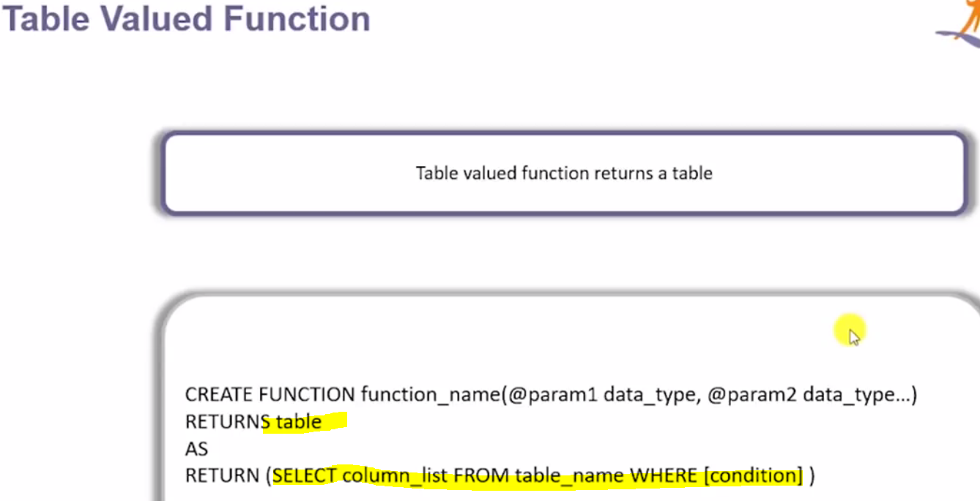

Table valued function return a table instead of scalar value. So here the return type is table. As we can see that there is no Begin and end keyword.

|  |  |
| --- | --- |
| **To execute the above created function:** | Output: |
|  |  |

So in this way we create and execute the function.

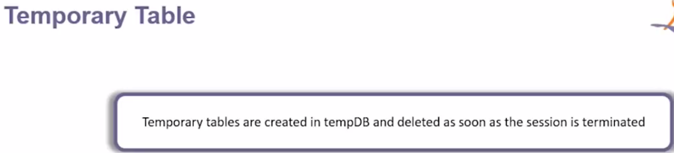

And it is useful in processing intermediary data.

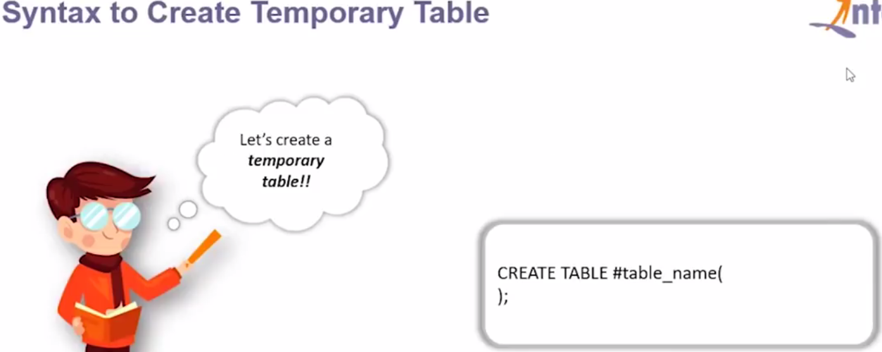

So here while creating temporary table we have use (#) as shown in the index. This # symbol signifies that this table is temporary table

|  |  |
| --- | --- |
|  |  |
| If we execute the select statement then we will get the columns. And similary to insert the values in the temprary table we will use # |  |

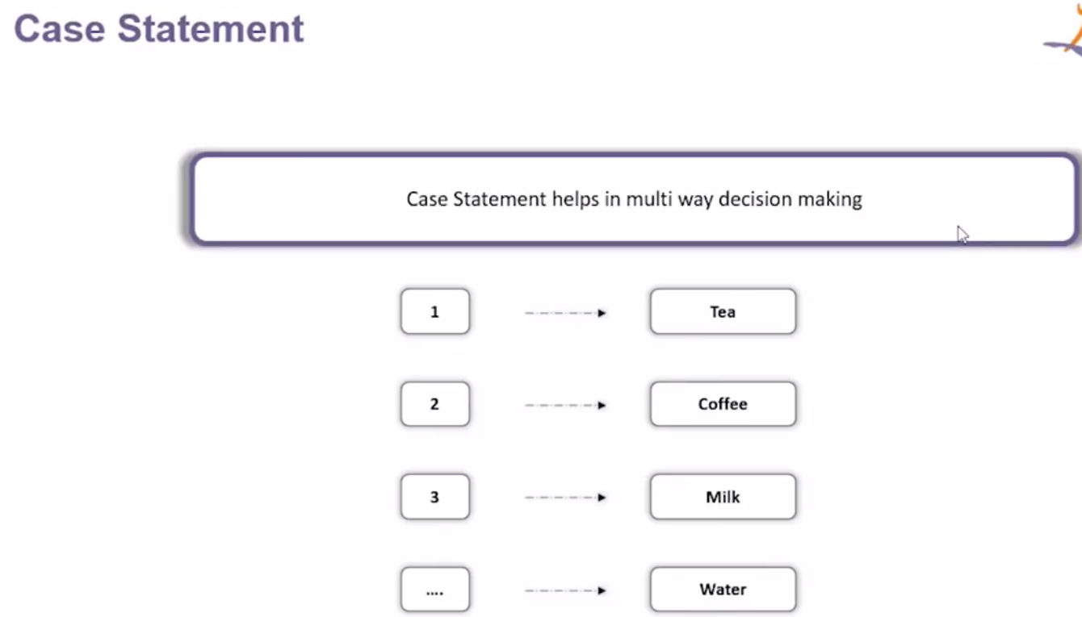

For example if we select 1 then it gives Tea , if 2 then it gives Coffee and if give any other key then it returns Water.

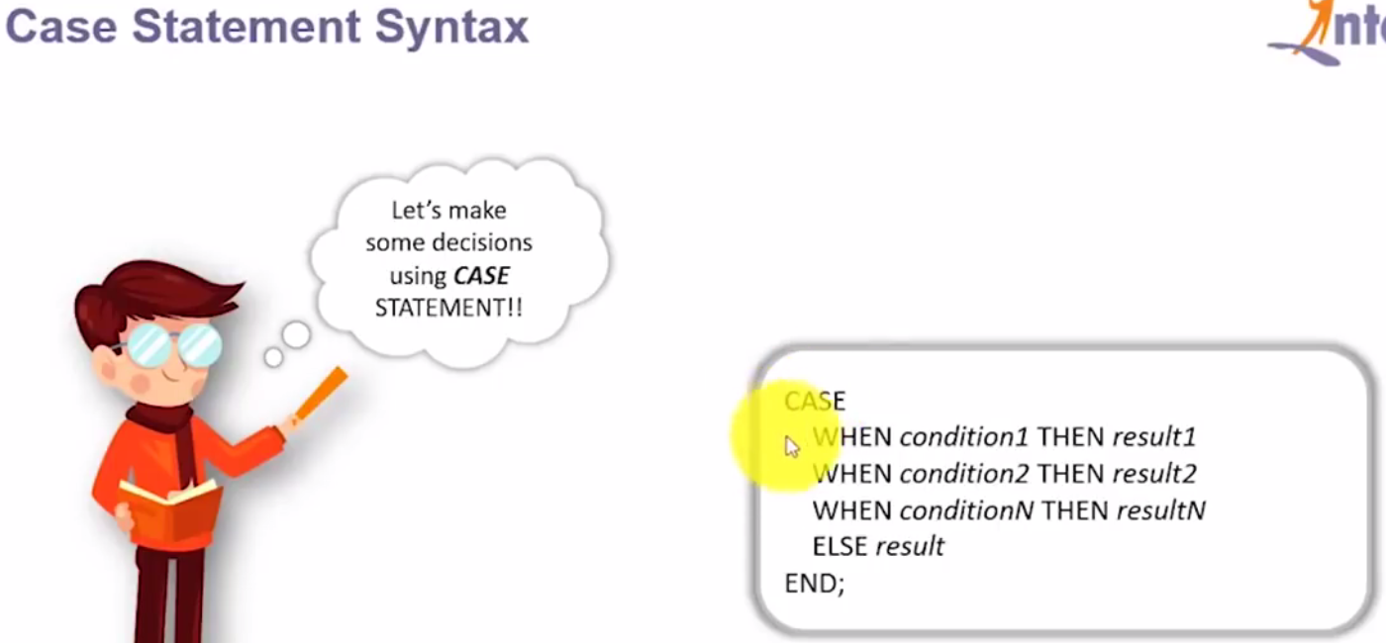

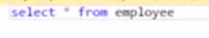

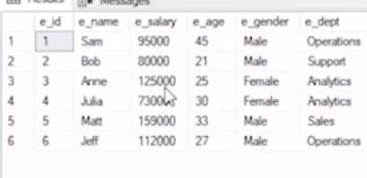

As here we have employee table having the above fields now let’s by using Case statement add grade based on the salary

|  |  |
| --- | --- |
|  |  |

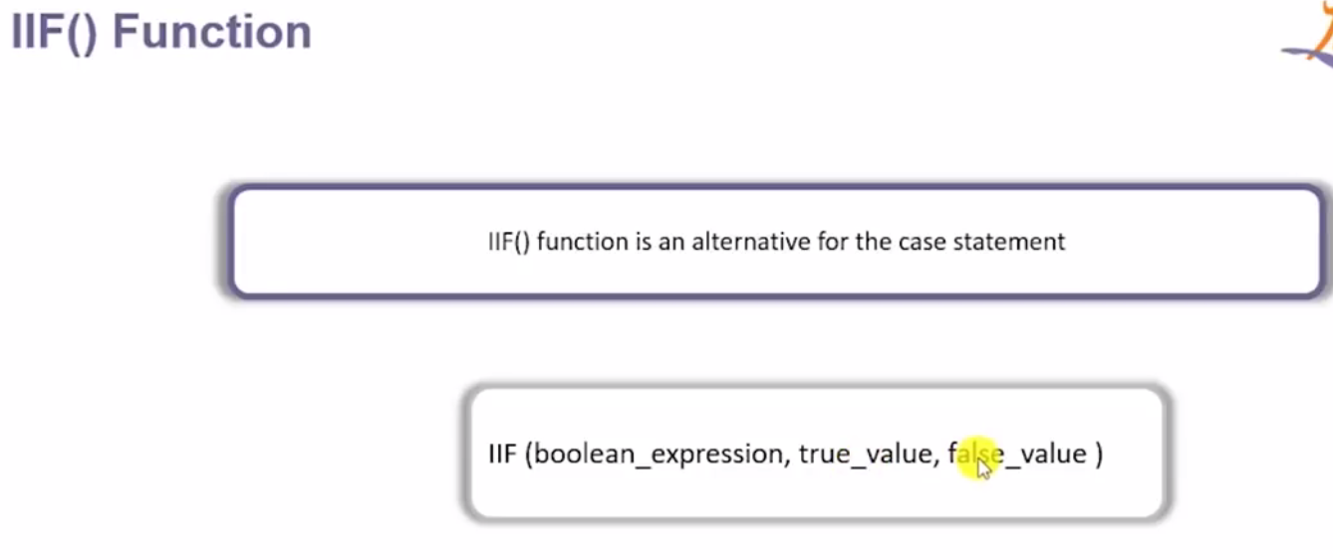

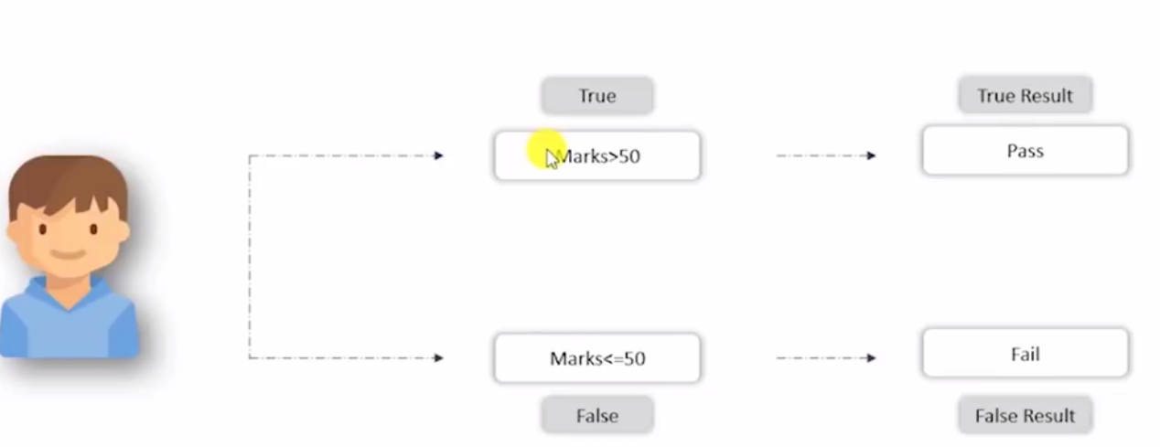

|  |
| --- |
|  |

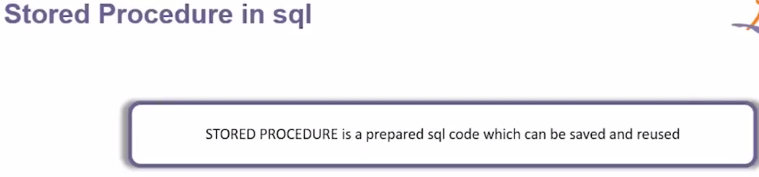

So here we have sql query that we have to use in most of the places then we can save it and just all it with name whenever is required.

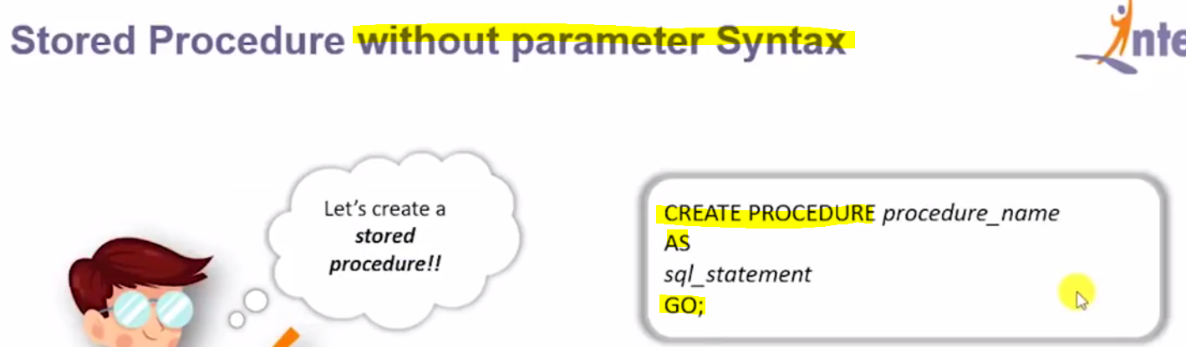

Here the sql_statement is nothing but the query for which we will create the procedure. After creating the procedure we can execute the procedure using below syntax.

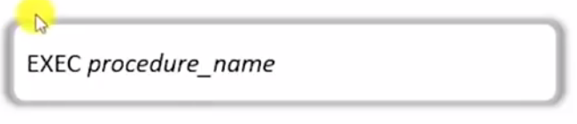

|  |  |
| --- | --- |
| Here we have created two procedure and executing them using exec procedureName | In the first procedure we have created the procedure to select age from employee table. And in the |

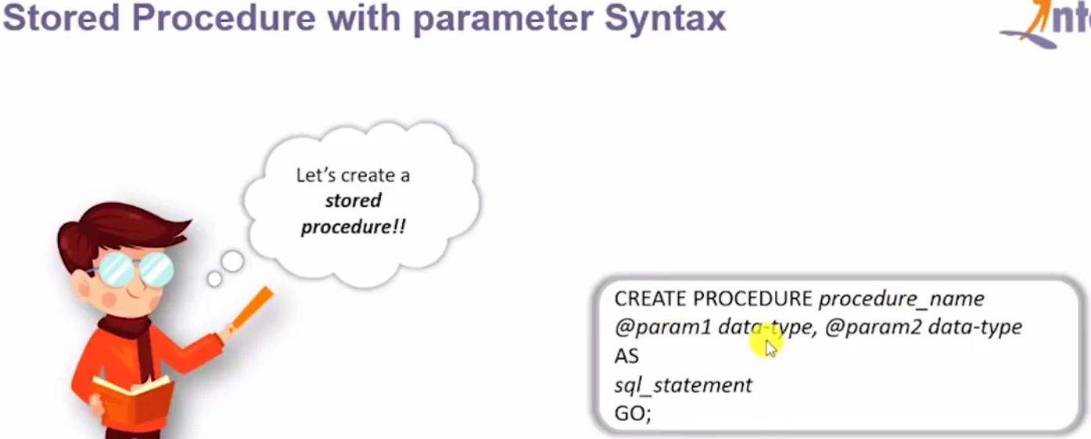

The only difference is that after the **procedure_name** we are providing the list of **parameters name and corresponding data types.**

|  |  |
| --- | --- |
| **Here we have created procedure name “employee_gender” with parameter @gender and data type varchar and after as, in the sql statement where clause passing this parameter as give given above** |  |
| **Now let’s execute the created procedure. And pass value in the parameter ‘male’** | **So we have got all of the male from employee table** |
| **It will provide the detail of female employees.** |  |

**So this how we can create stored procedure with or without parameter.**

**Trigger in SQL:**

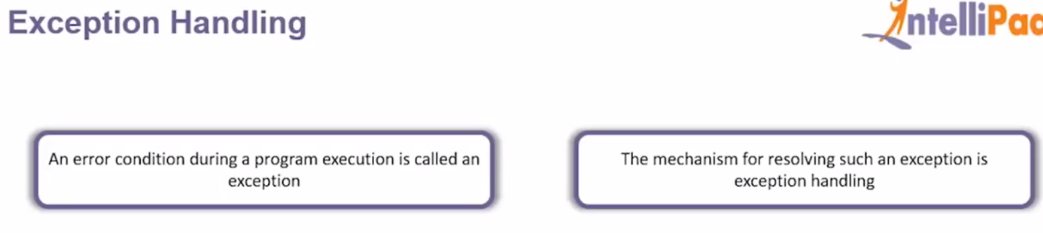

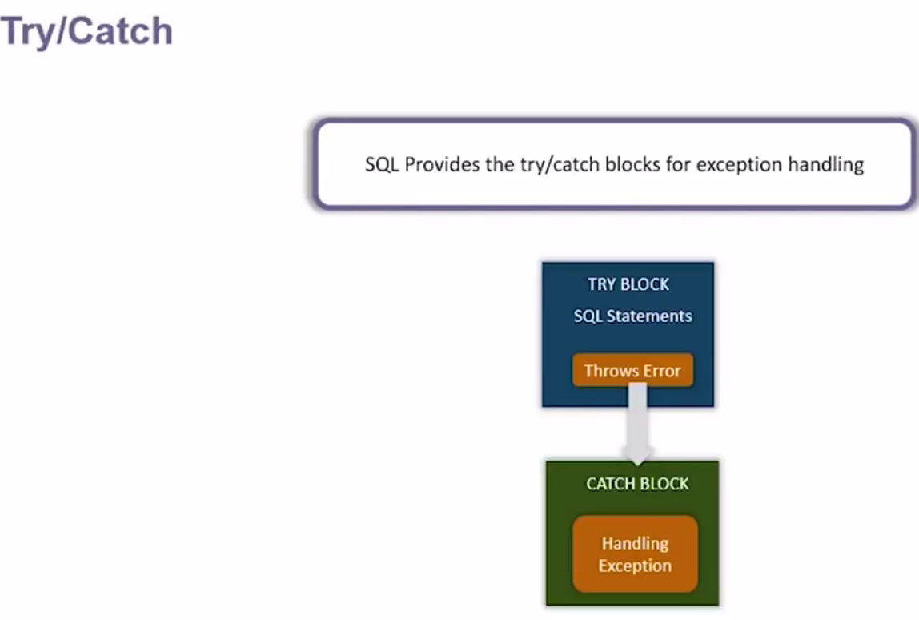

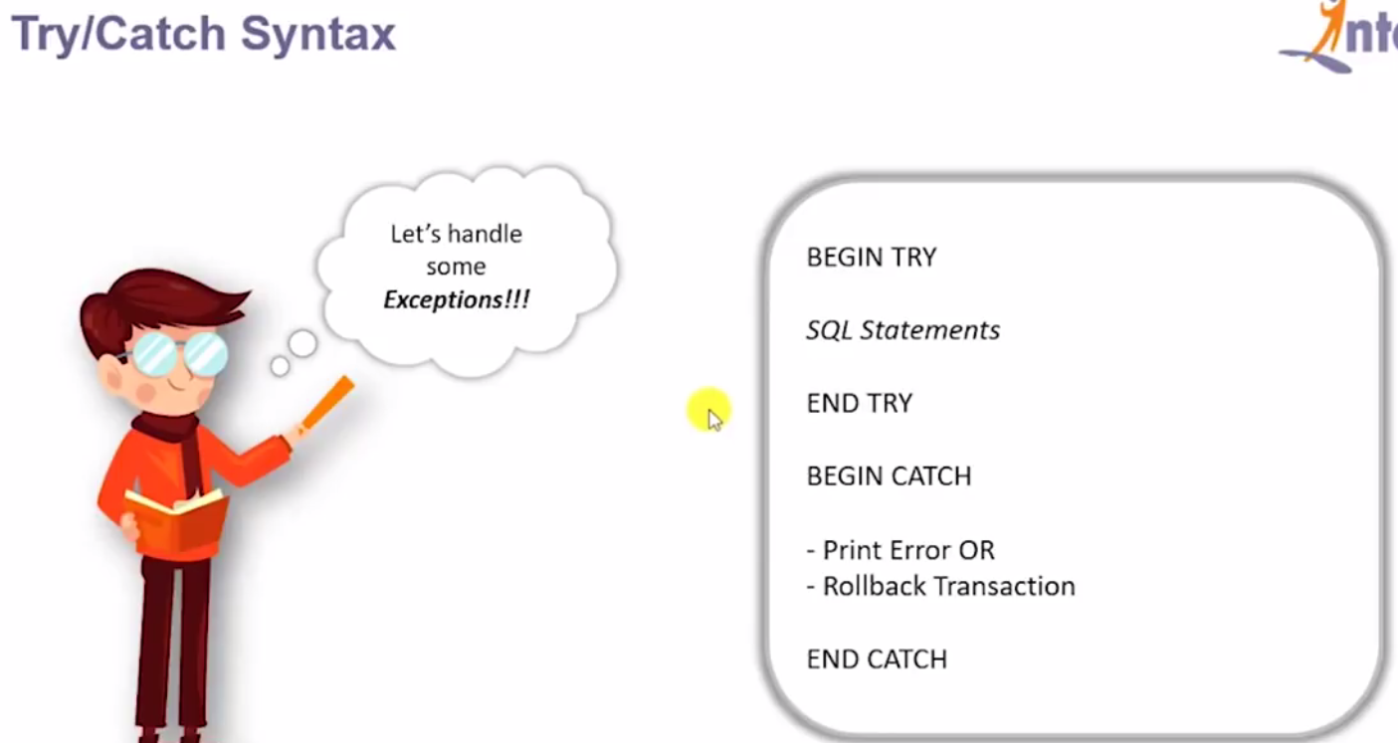

**So sql statement will write between Begin Try – End Try and in the catch block either prints the error or rollback the transaction.**

|  |  |
| --- | --- |
|  | **So here we have declare two variable of int type and in the try block dividing it by zero and in the catch block we are printing the default error_message()**  **And so when we will execute this then got exception**    **We can define our own user-defined messages.** |

|  |  |
| --- | --- |
|  | **Here we are adding int with varchar and in the catch block trying to print custom essages as given below.** |

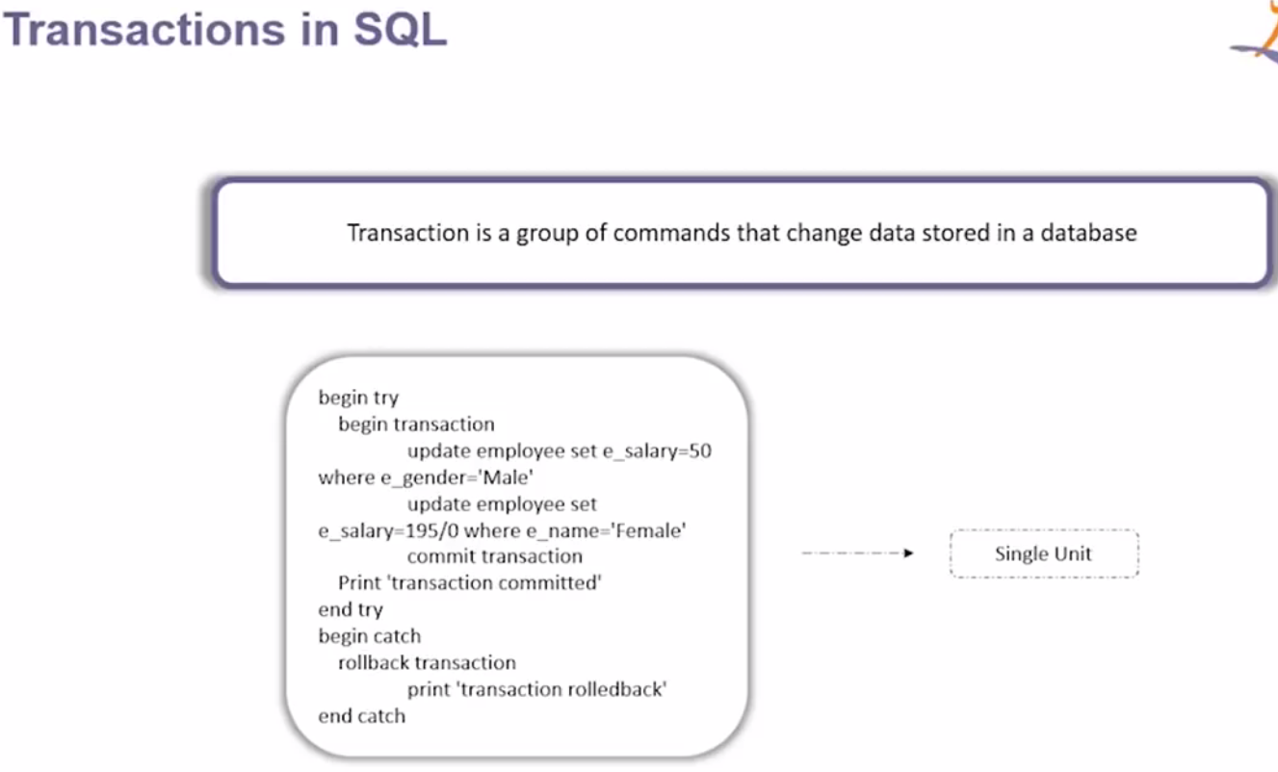

So this transaction performs several commands and is treated as a single unit. This transaction ensures that either all the command executed successfully or none of them. So let’s say any of the command fails then the transaction also gets failed and the data which would have got updated would be rolled back.

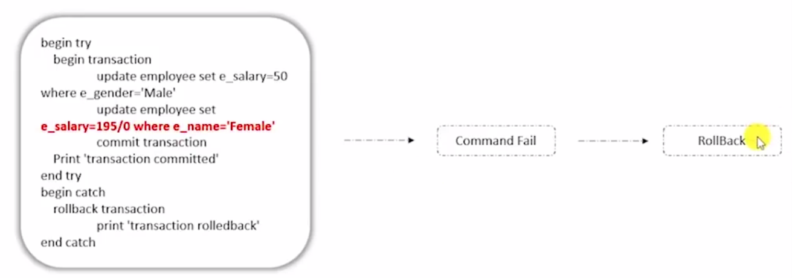

And if all the transaction gets success then only updated data gets committed.

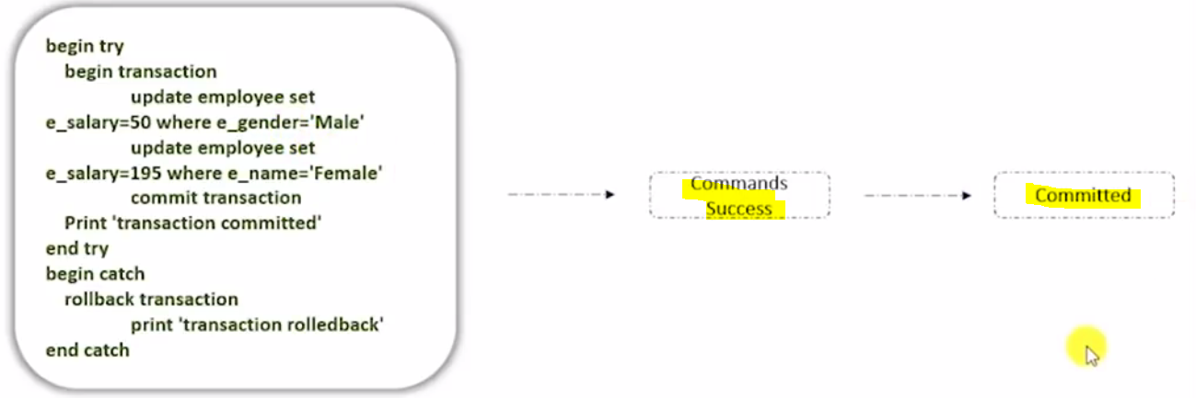

So transaction ensures the integrity of data.

|  |  |
| --- | --- |
|  | **So here we have begin transaction and inside the transaction we have updated age of sam** |
|  | **Now if see the updated age of the sam then age will updated as 30** |
|  | **Since this update command is inside the transaction so we can rollback using the ‘rollback transaction’ command and once we run rollback transaction the changed value will be roll backed from 30 to original** |
|  | **Now if want to commit the updated row then we have to use command ‘commit transaction’**  **Once the changes get committed then we cannot rollback it.** |

Another example:

|  |  |
| --- | --- |
|  | **So here inside the begin transaction we have written two update command and after that commit the transaction and print transaction committed.**  **Now if any exception occurs like in the second update divide by zero then catch block will be executed and the transaction will be rolled back and print the message ‘transaction rollback’** |

No if we write the second update command as: 

And run the above transaction the we will get message like ‘transaction committed’

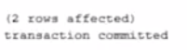

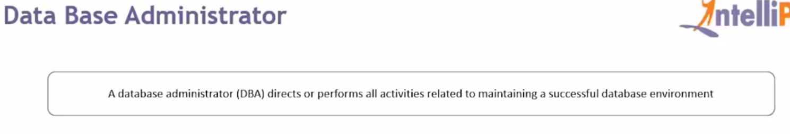 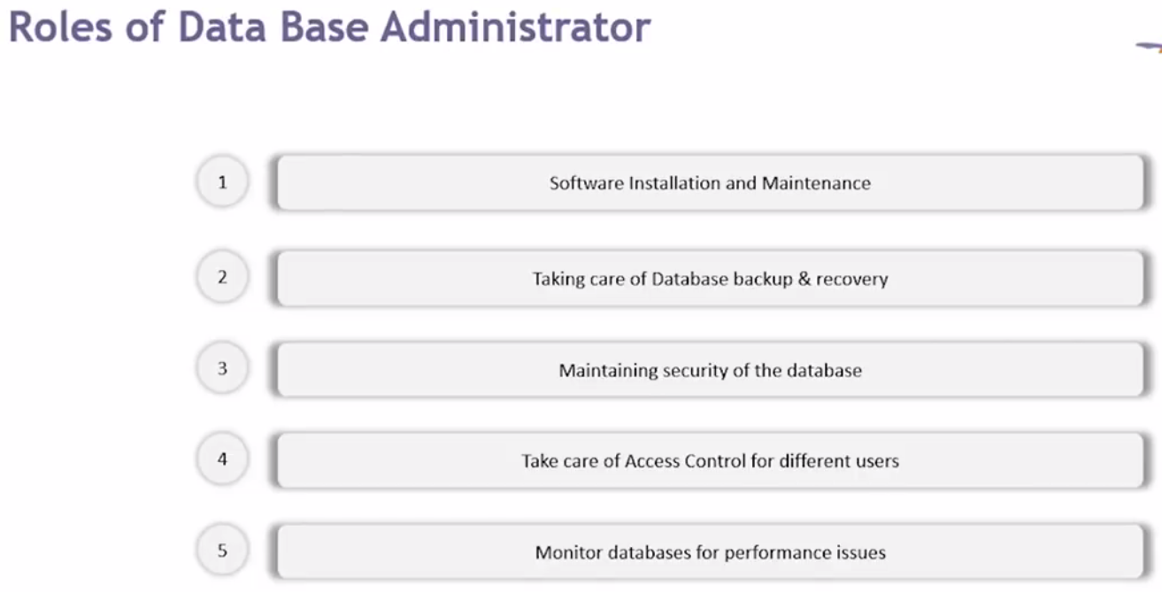

 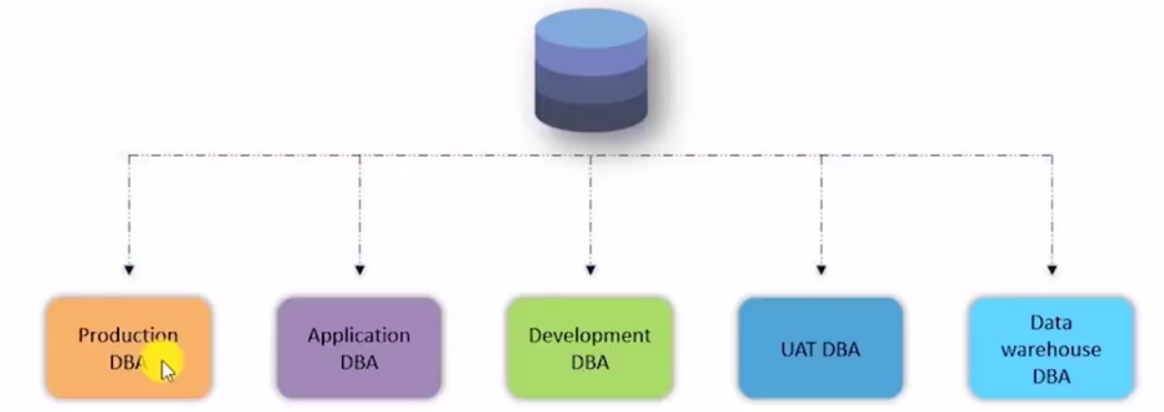

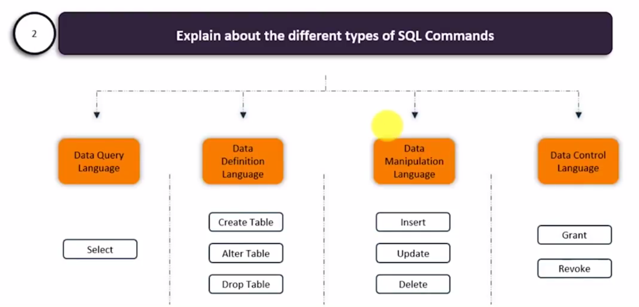 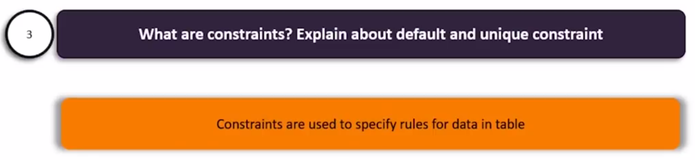 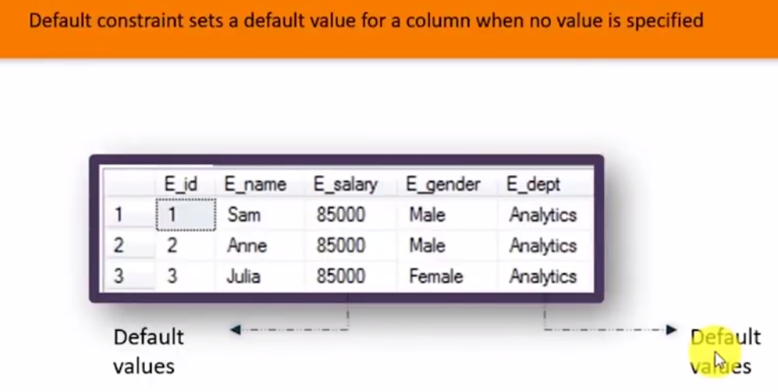

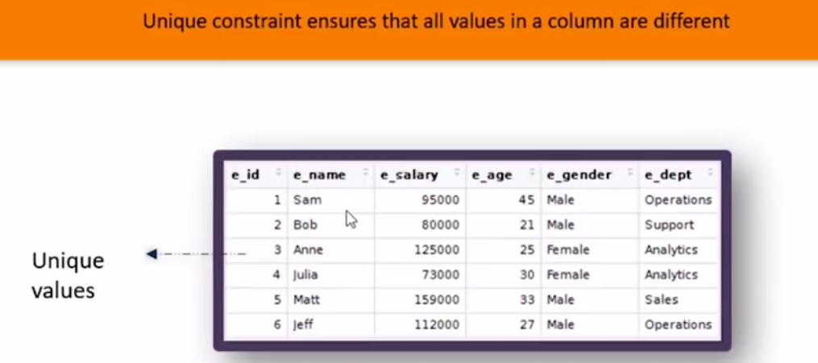



If we try to insert the duplicate value then we will get error



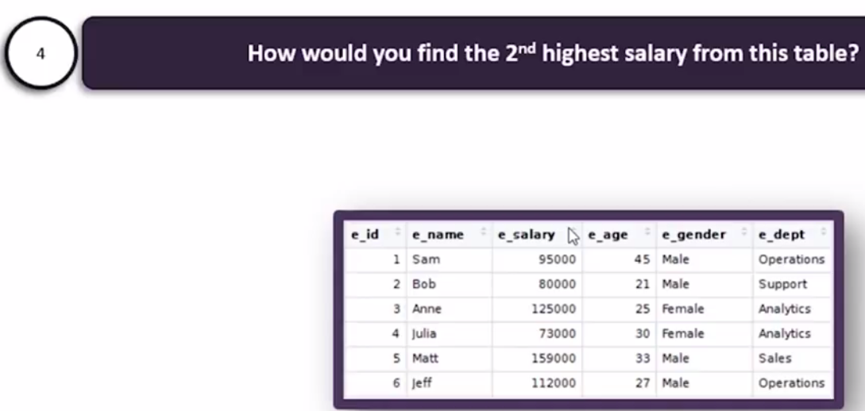 

And we will get 125000

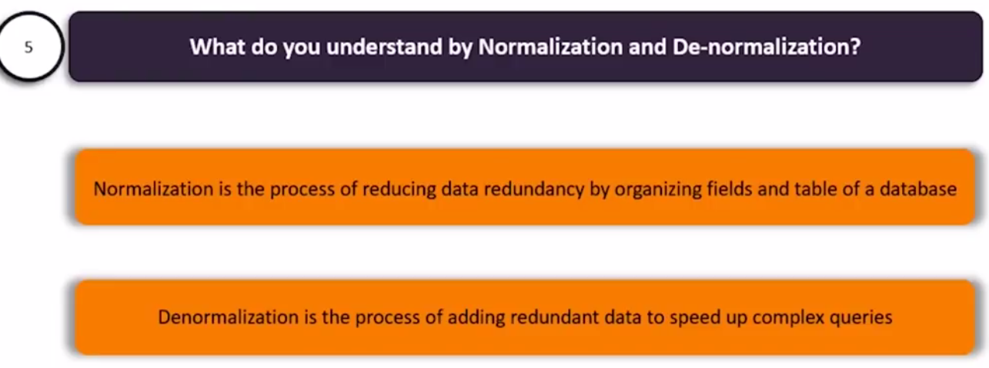

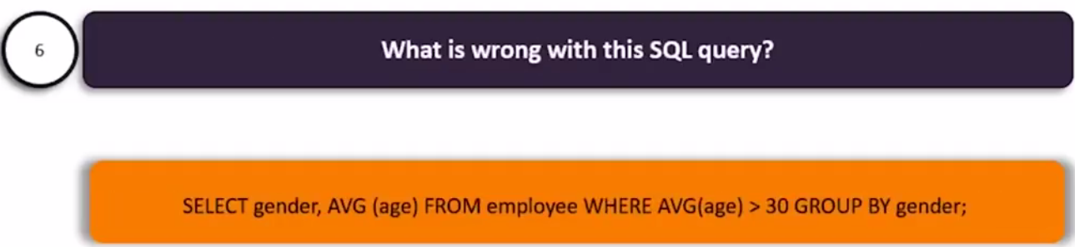

So whenever we are using aggregate function then we cannot use where clause and instead of where we have use having clause



And having clause must be use after group by clause so the correct query would be.



And now we will get the correct result.

 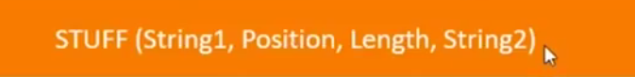

It is a function with given parameter as shown above.



Output :

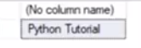

So here replacing position 1 i.e. tutorial with string python after length 3(SQL)

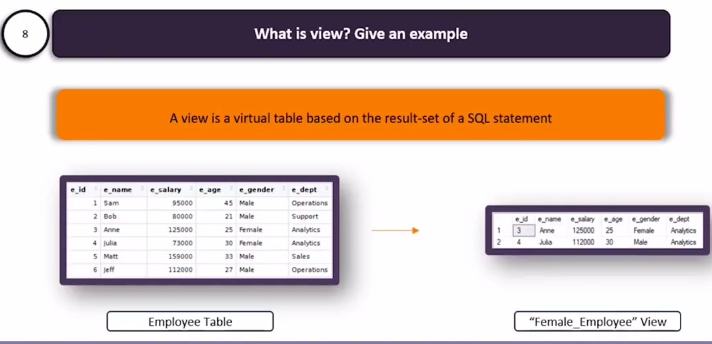 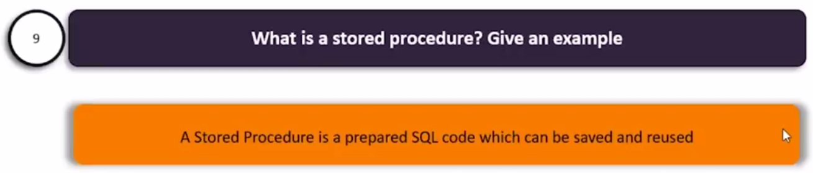 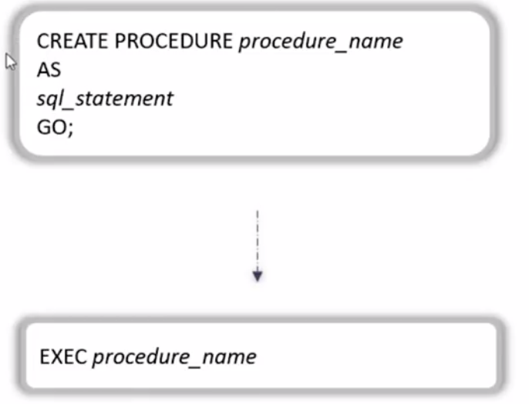

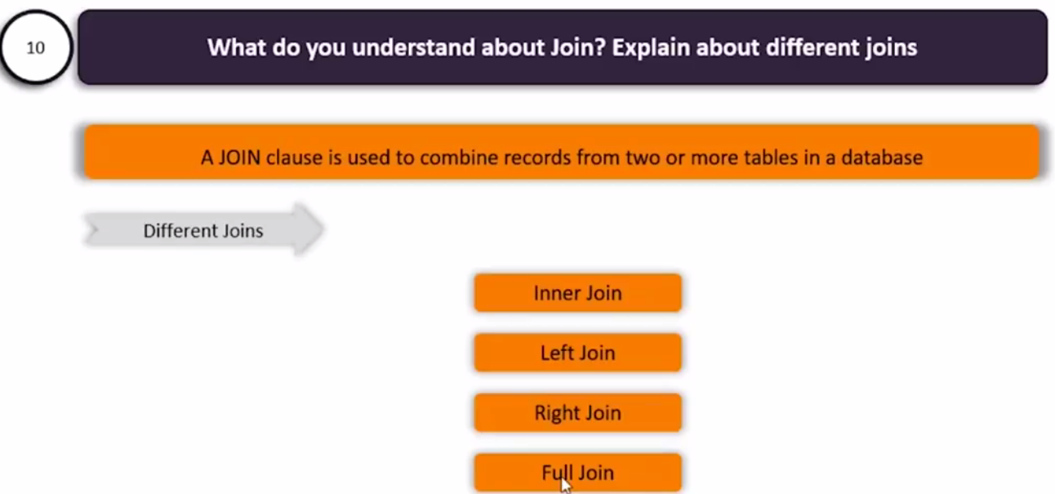 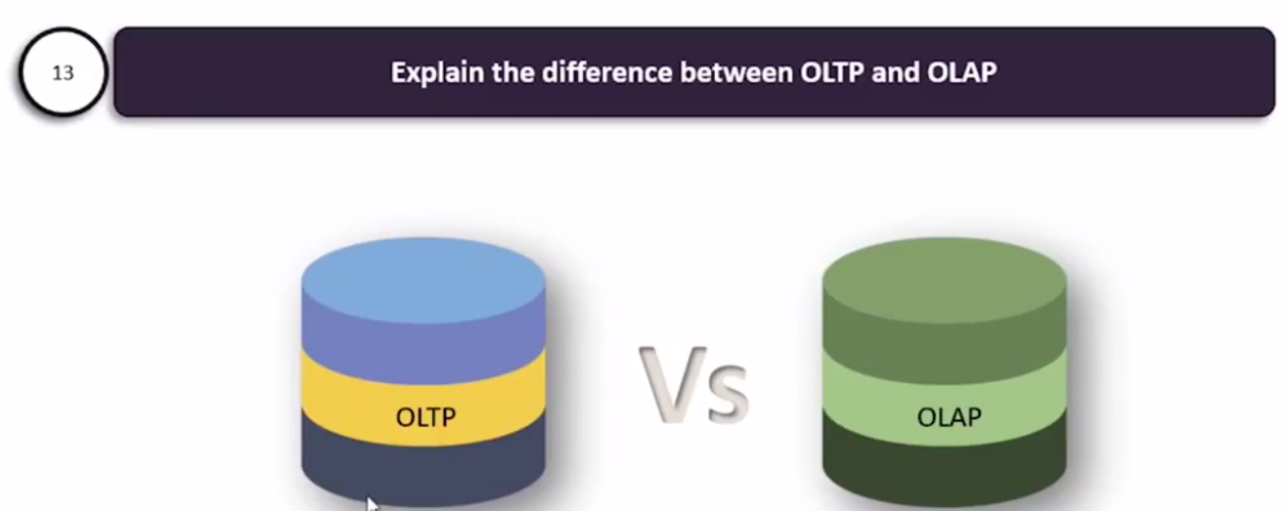

OLTP- Online Transaction Processing. Use for distributed transaction to avoid the single point of failure.

OLAP-



    
    
    